**Cloud Computing**

**Course Code: MEAD-658**

**Lab Practical File**

**Submitted by**

**Shantanu Shukla**

**01211805424**

**in partial fulfillment for the award of the degree**

**of**

**Master of Technology (AI & DS)**

**batch of 2024 - 26 (2nd Semester)**



**Center for Development of Advanced Computing, Noida**

**Affiliated to Guru Gobind Singh Indraprastha University**

**INDEX**

|  |  |  |  |
| --- | --- | --- | --- |
| 1. **No** | **Title** | **Page No.** | **Signature** |
| 1 | **Lab-1:** Explore the following networking commands:   * ipconfig * ping * tracert * whois * netstat * etc.. | 3-5 |  |
| 2 | **Lab-2:** Create AWS free account and explore the services offered by AWS | 6-9 |  |
| 3 | **Lab-3:** Create an EC2 instance in AWS and access it from your host machine | 9-13 |  |
| 4 | **Lab-4:** Host a static website using S3 in AWS | 14-18 |  |
| 5 | **Lab-5:** Perform a comparative analysis of the services offered by Google, AWS and Microsoft clouds | 19-20 |  |
| 6 | **Lab-6:** Create a windows EC2 instance and prepare a database server to be accessed by a web application | 21-28 |  |

**Lab-1**

**Objective:** Explore the following networking commands:

* ipconfig
* ping
* tracert
* whois
* netstat
* etc…

**Results:**

* *ipconfig*

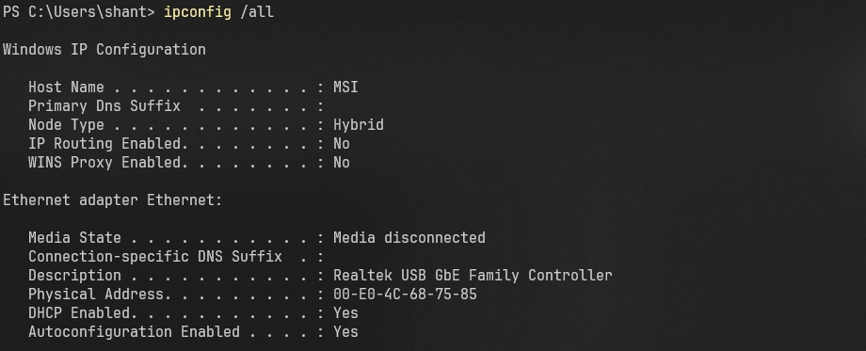

* *ping*

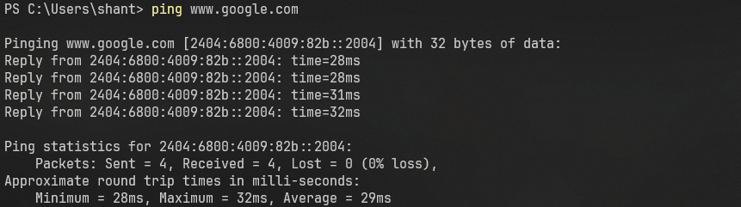

* *tracert*

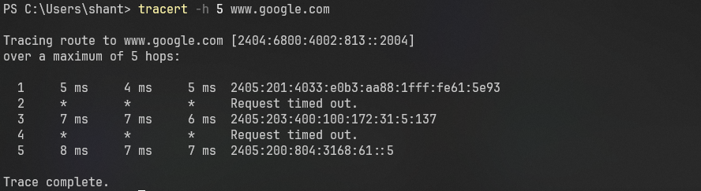

* *whois*

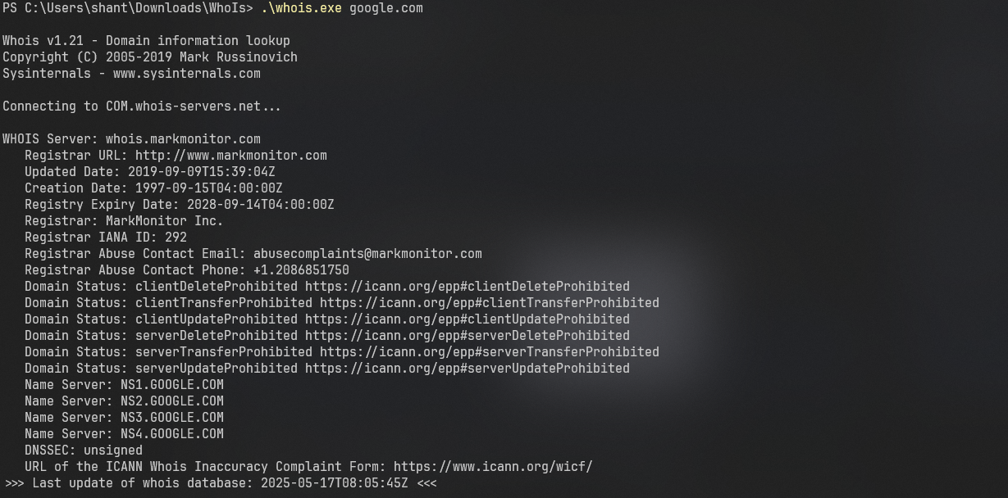

* *netstat*

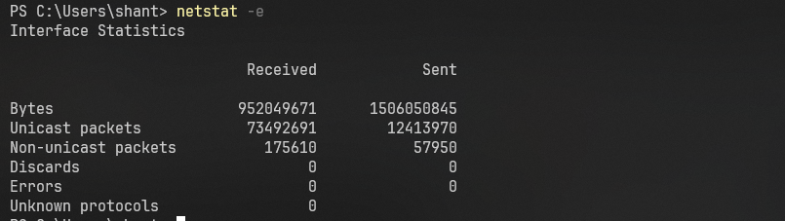

* *hostname*

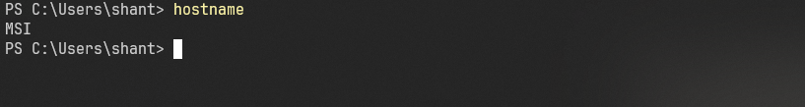

* *arp*

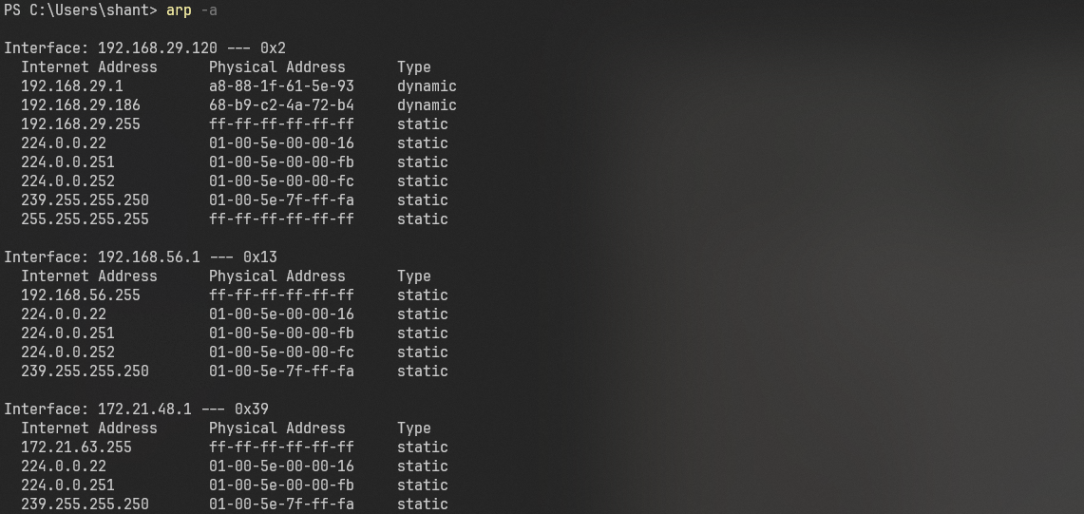

* *nslookup*

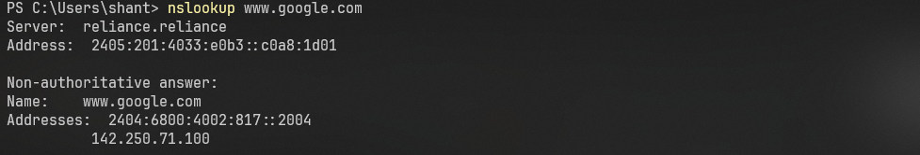

* *net*

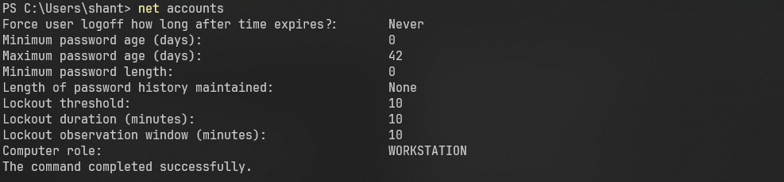

**Lab-2**

**Objective:** Create AWS free account and explore the services offered by AWS.

**Results:**

* *Account Dashboard*

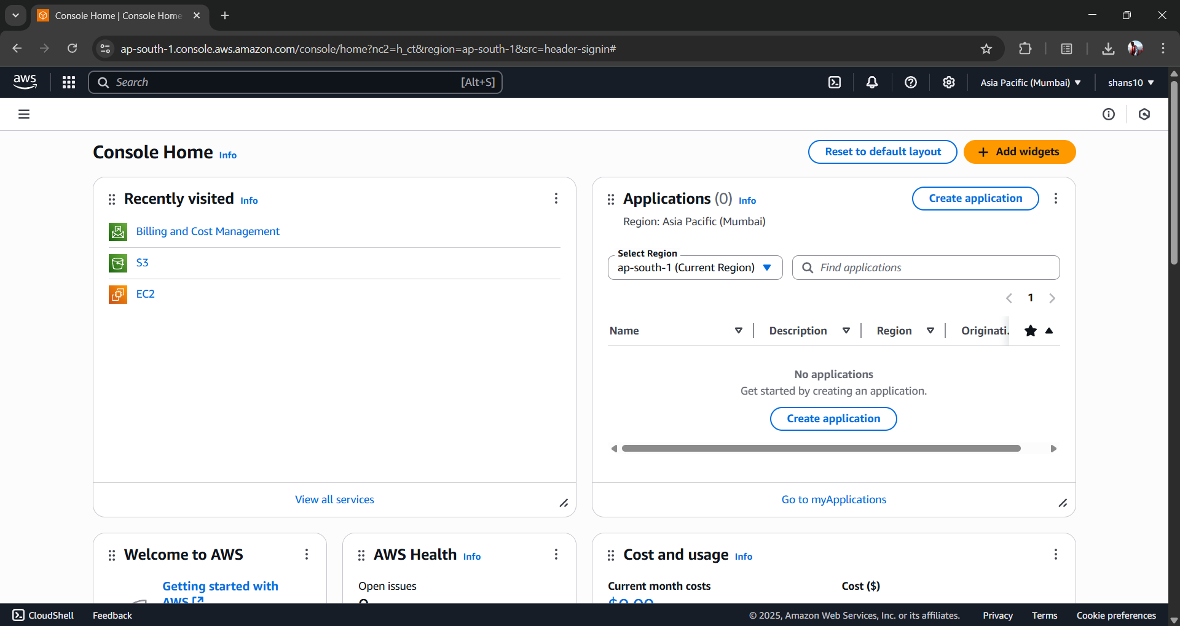

* *AWS Services*

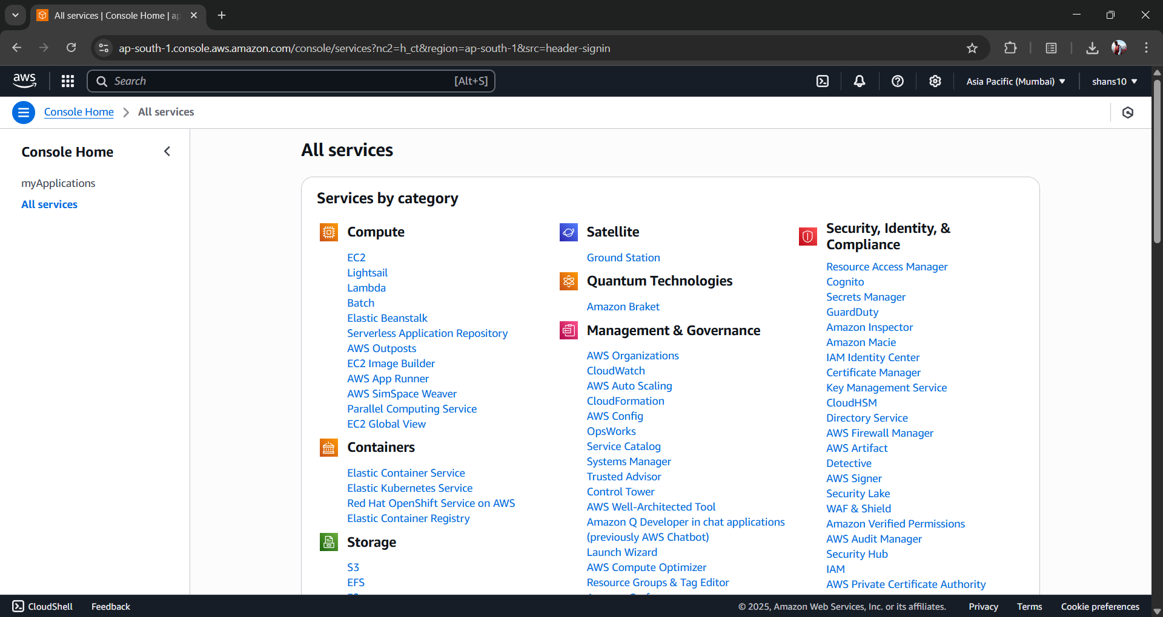

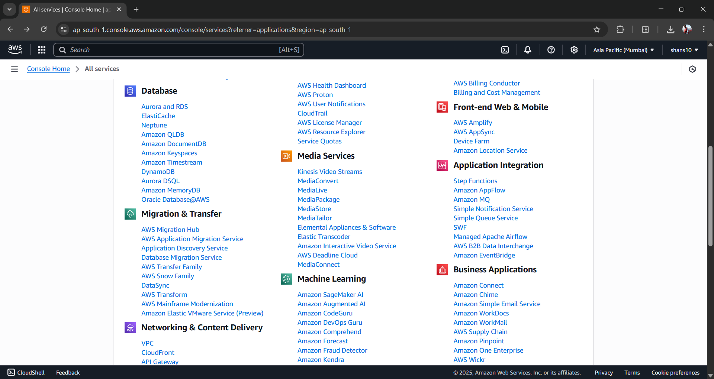

* *EC2*

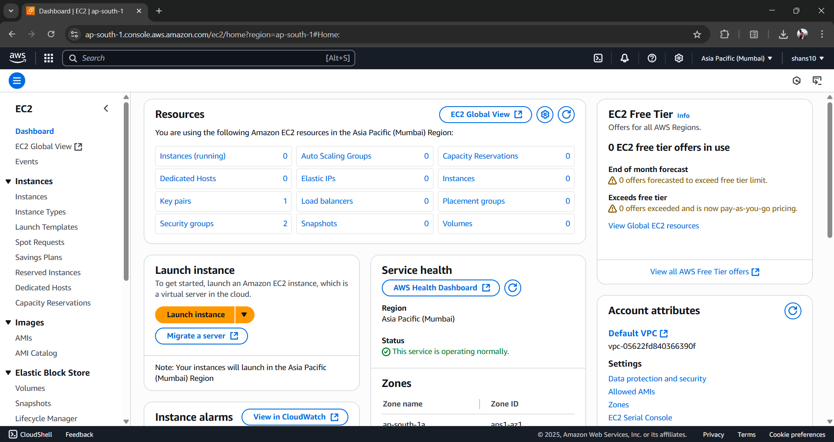

* *S3*

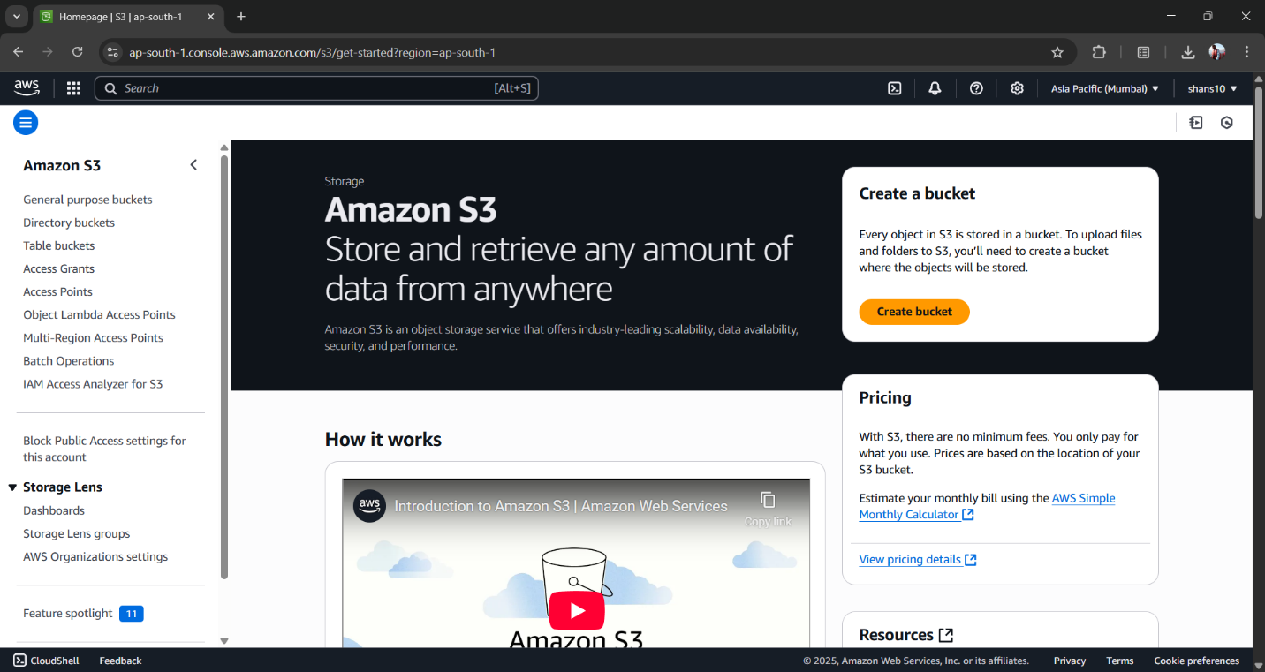

* *VPC*

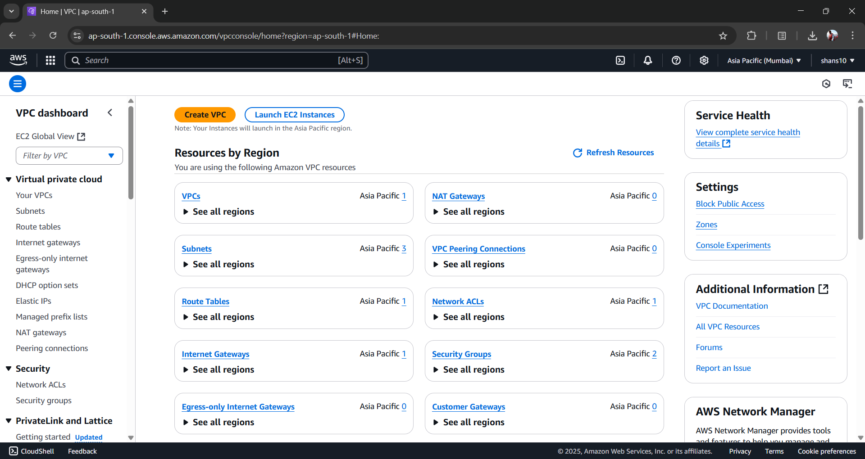

* *MyApplications*

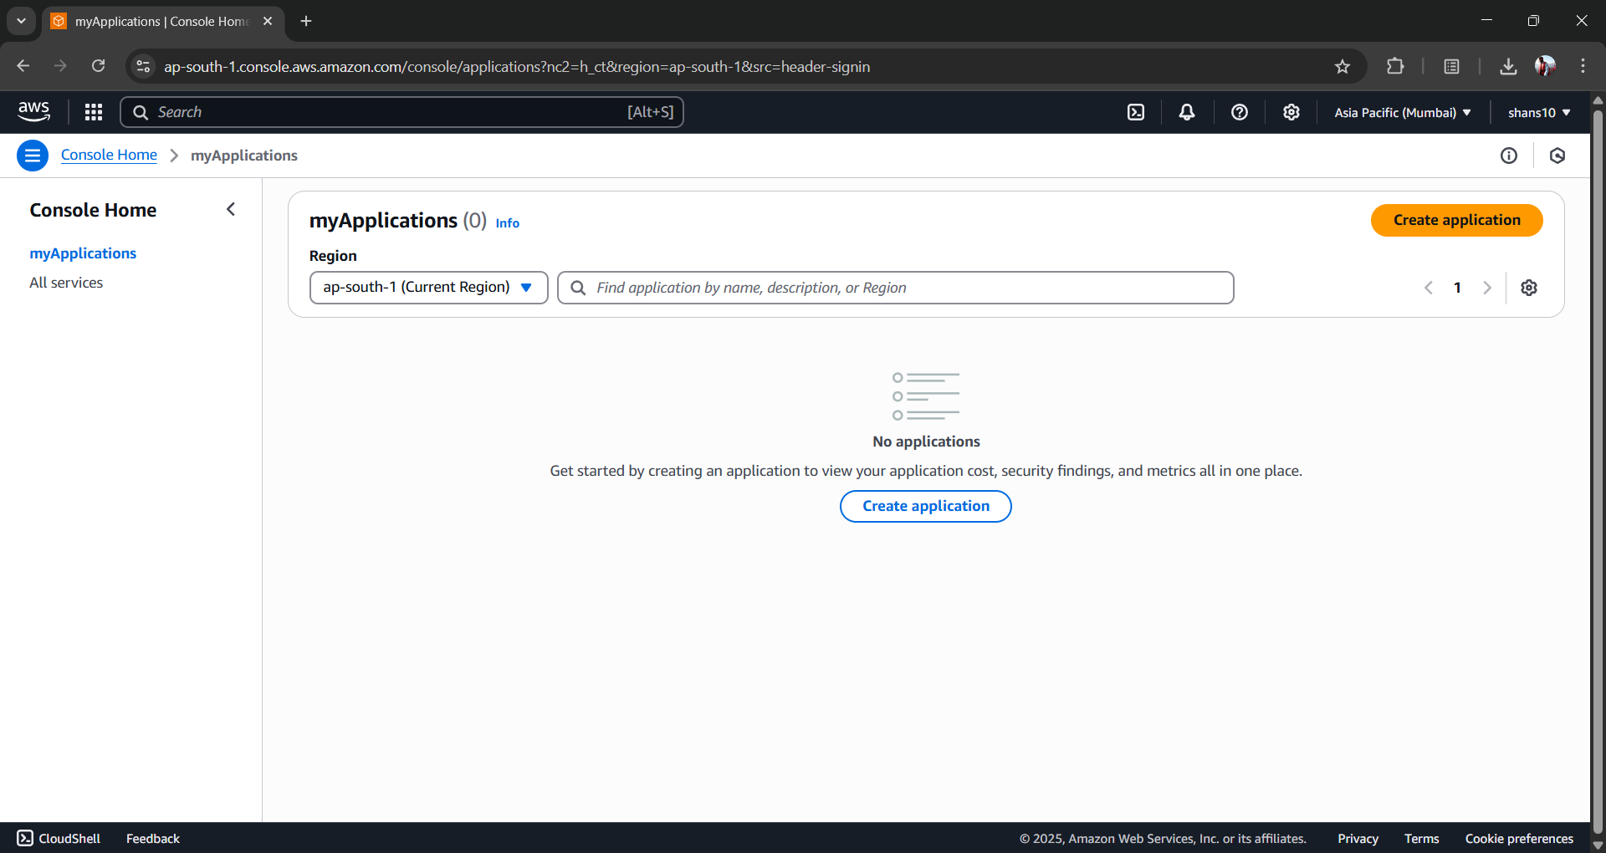

* *Create Application*

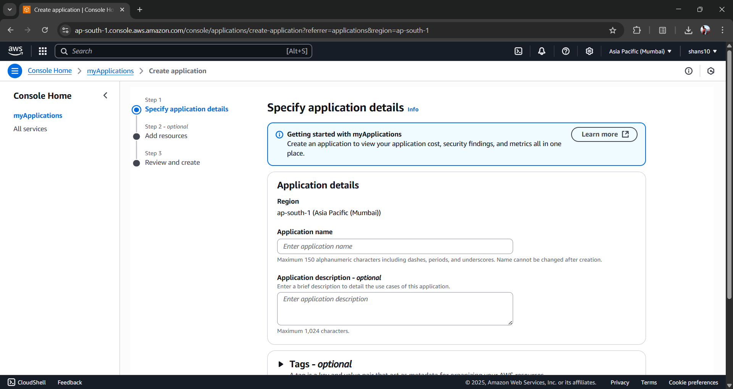

**Lab-3**

**Objective:** Create an EC2 instance in AWS and access it from your host machine.

**Results:**

* *Creating EC2 instance*

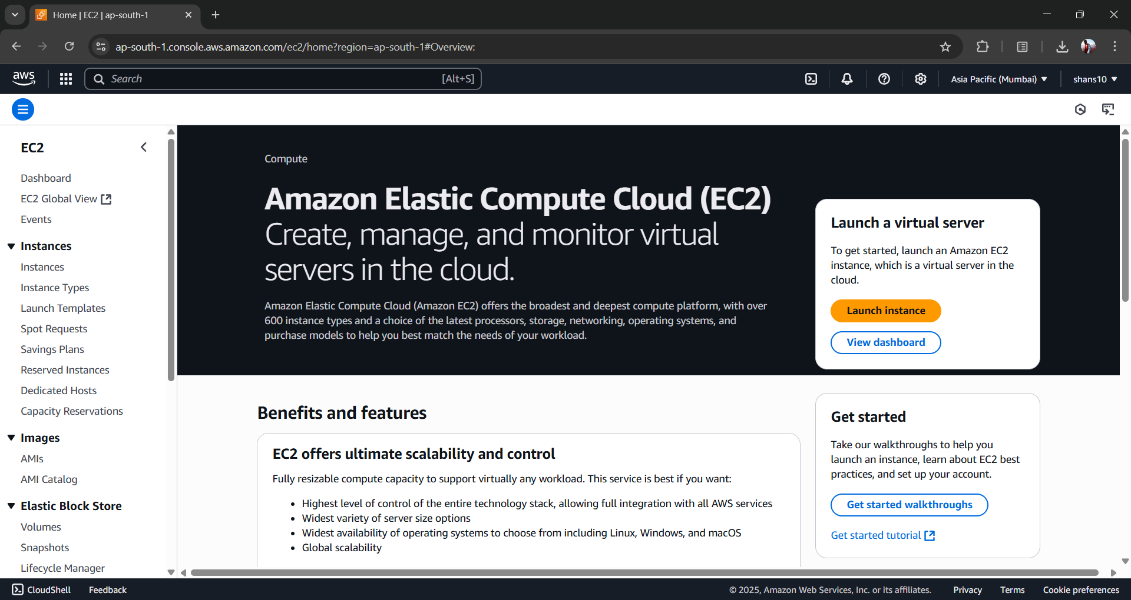

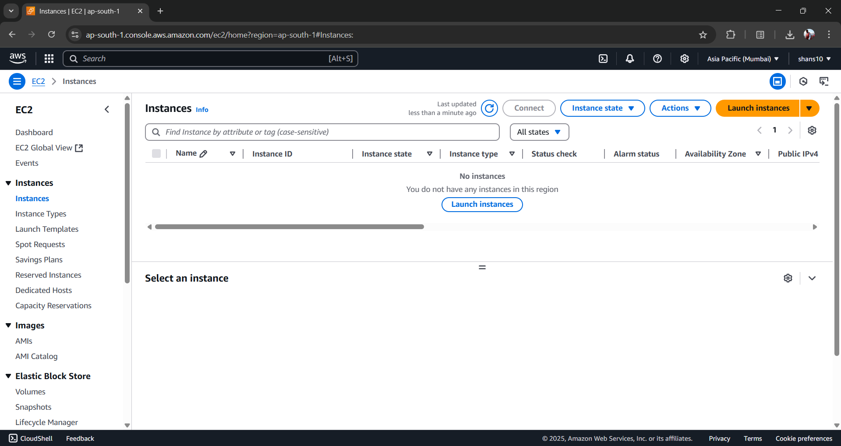

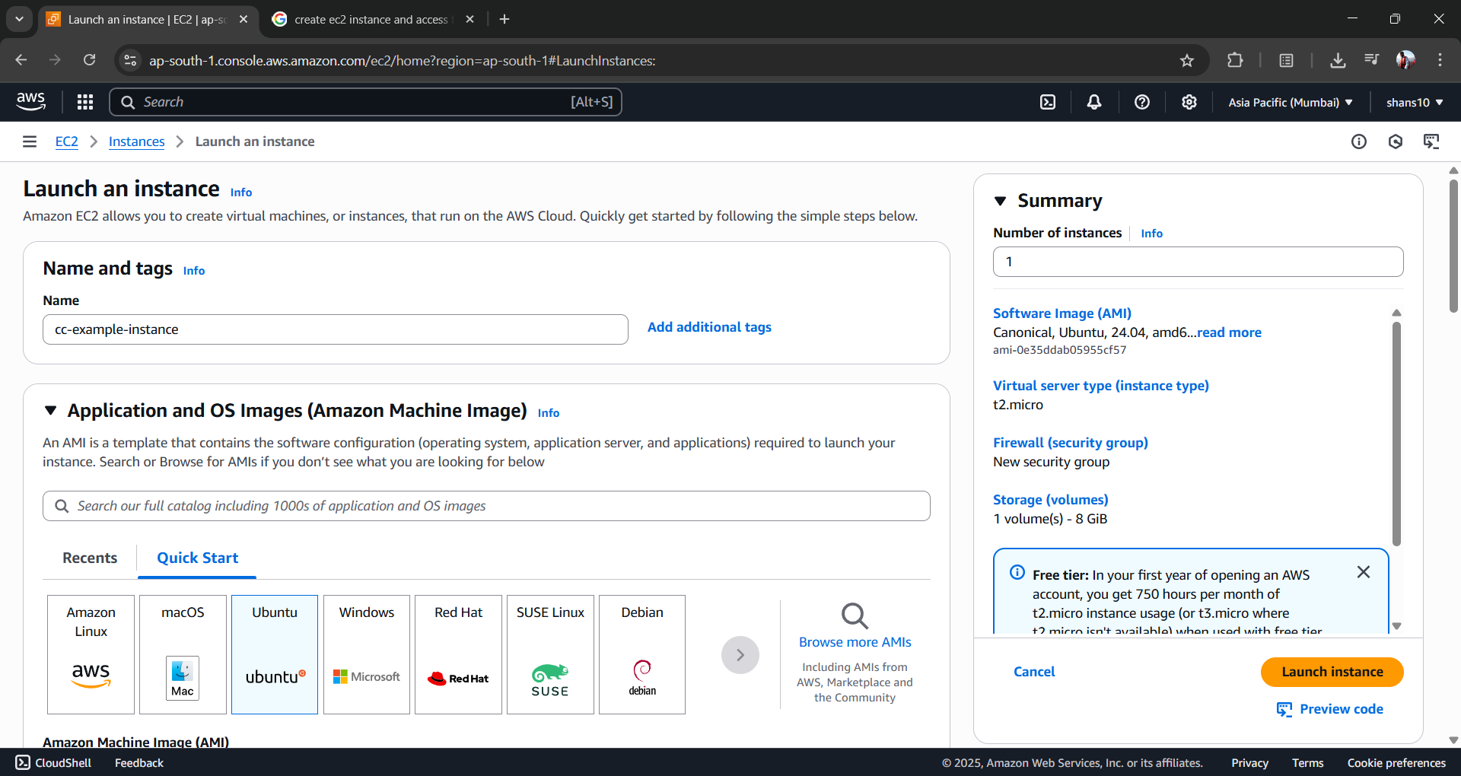

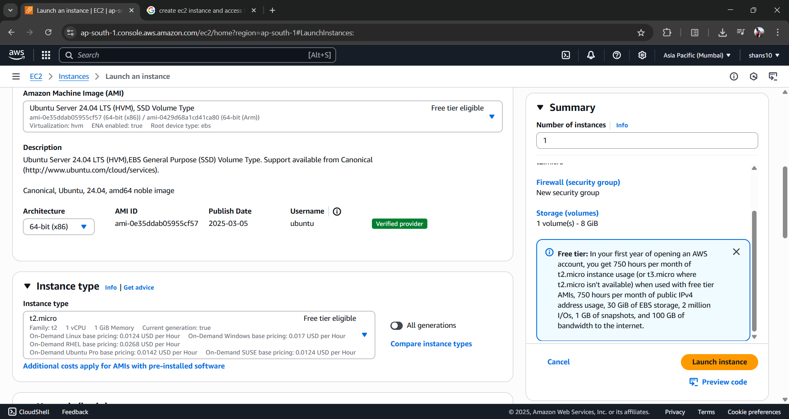

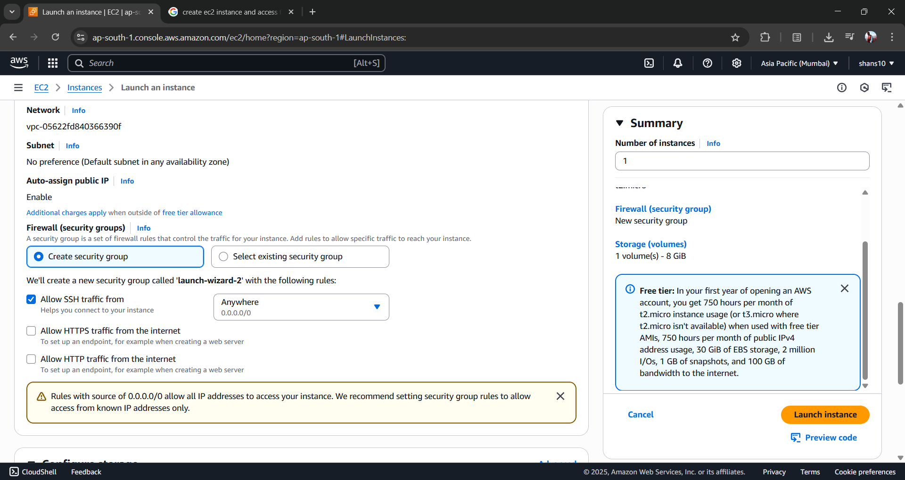

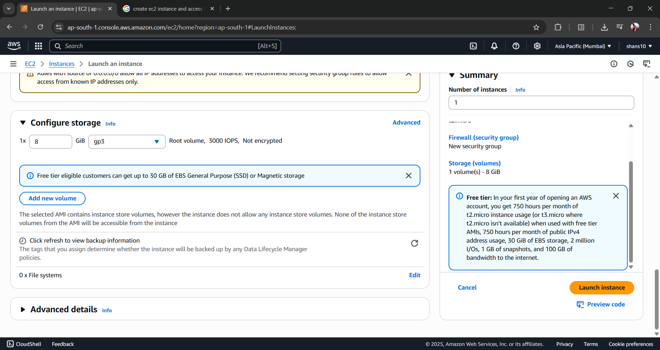

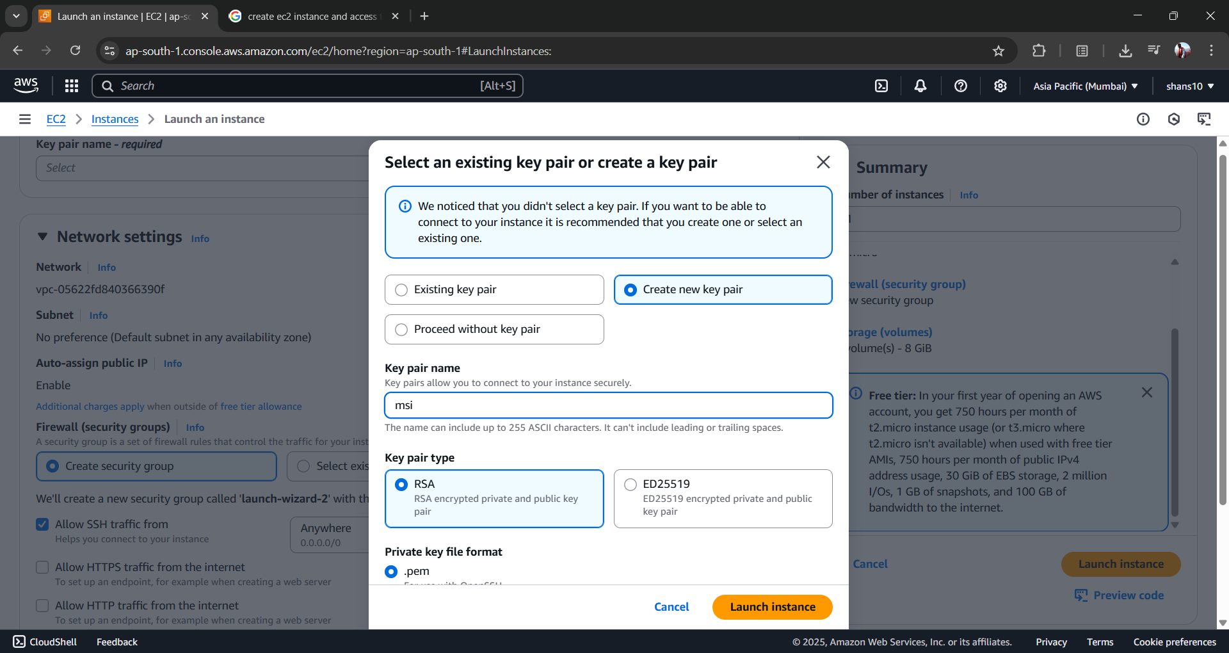

* *Accessing EC2 instance from host machine*

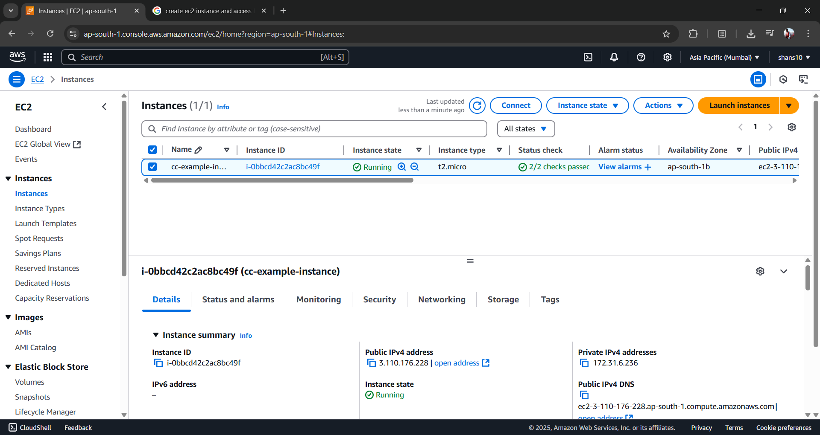

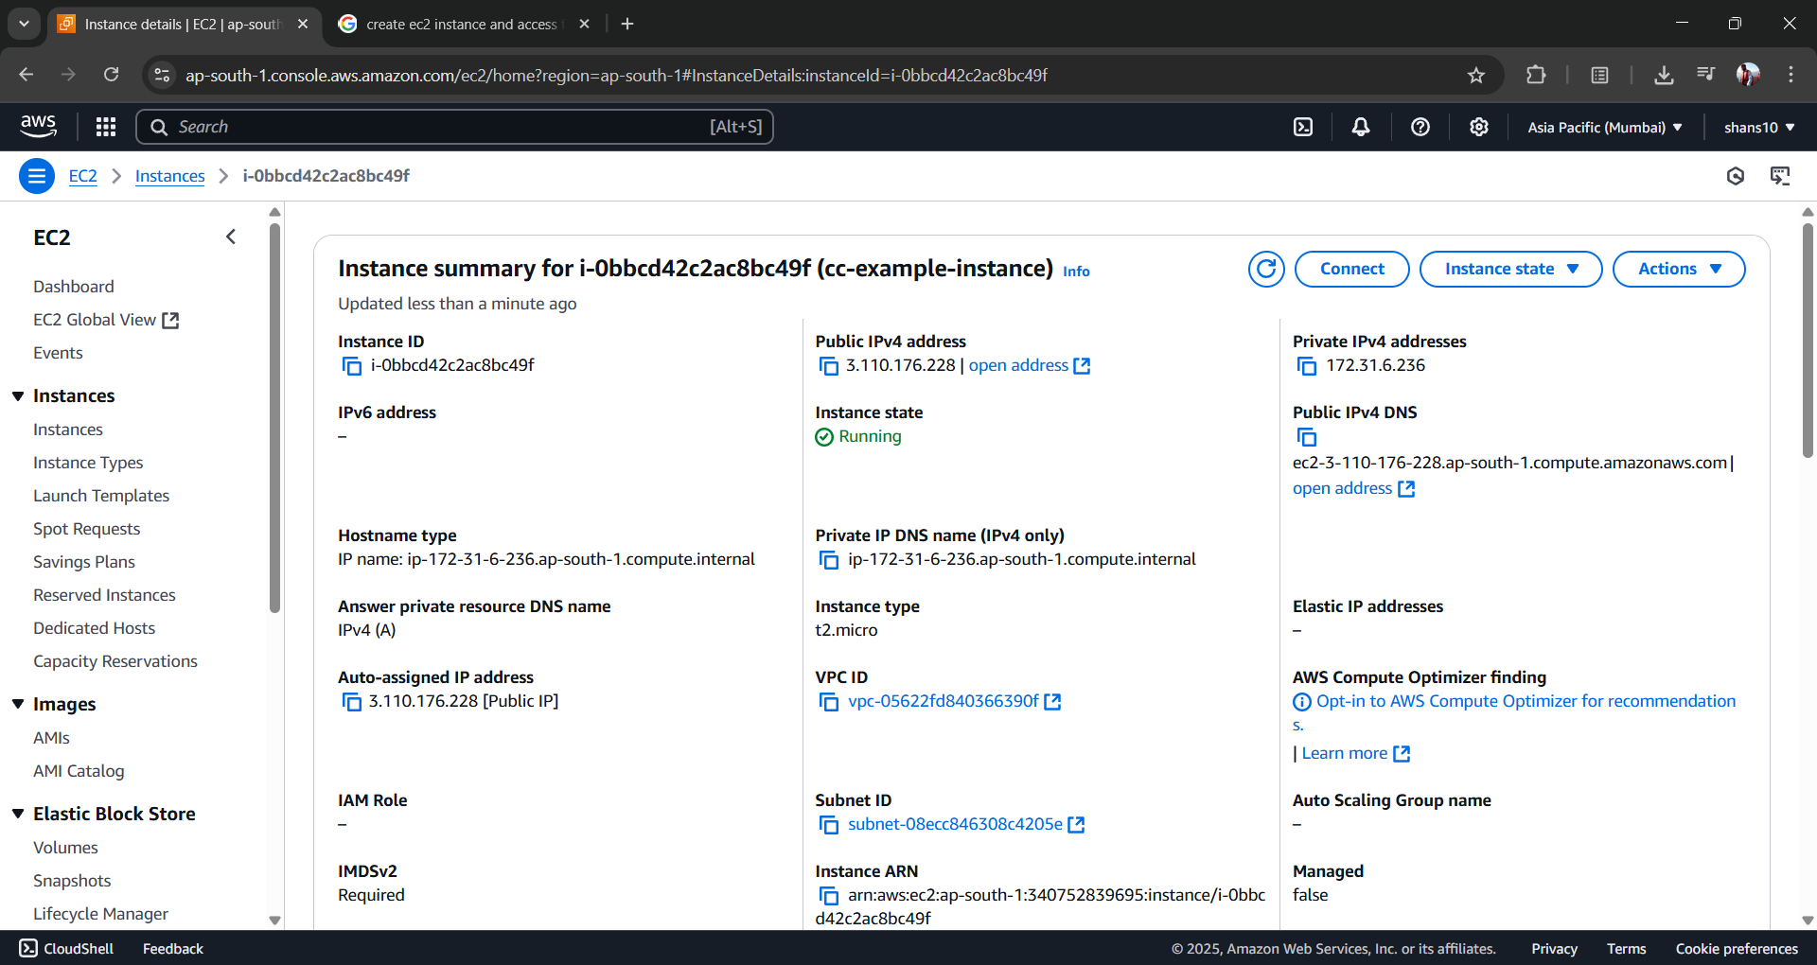

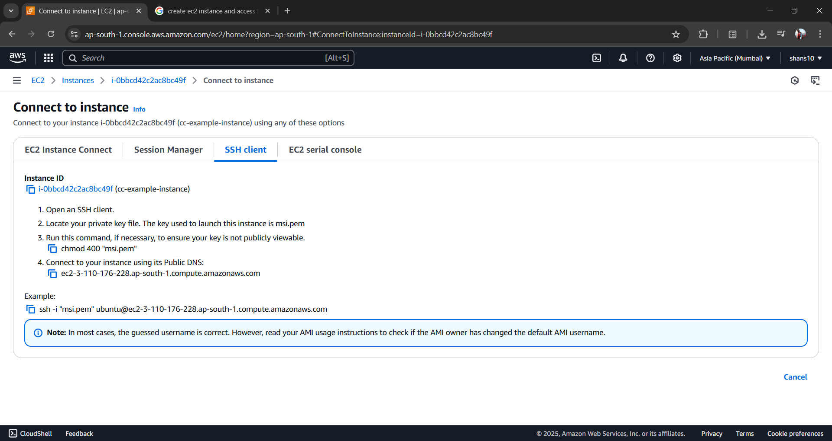

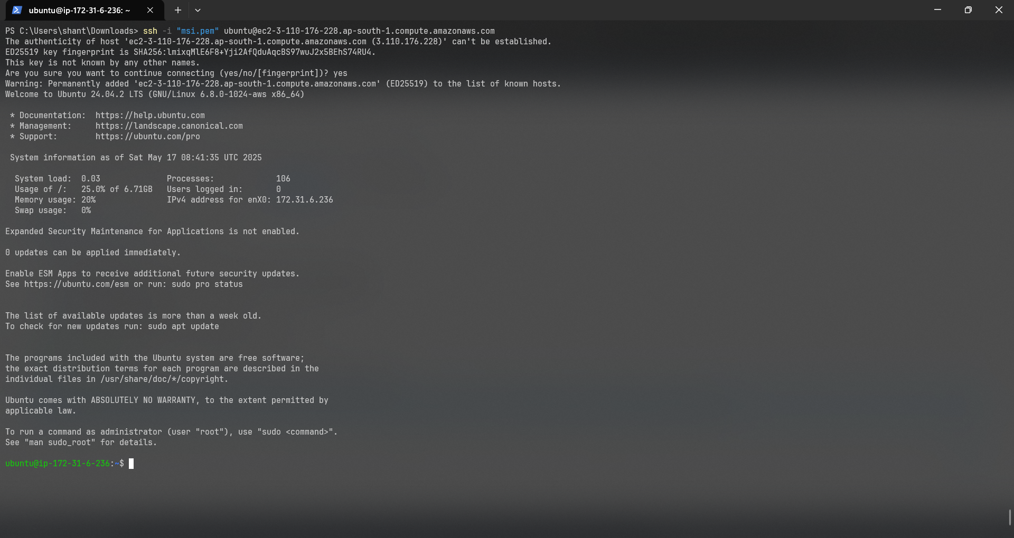

**Lab-4**

**Objective:** Host a static website using S3 in AWS.

**Results:**

1. *Create an S3 bucket -*

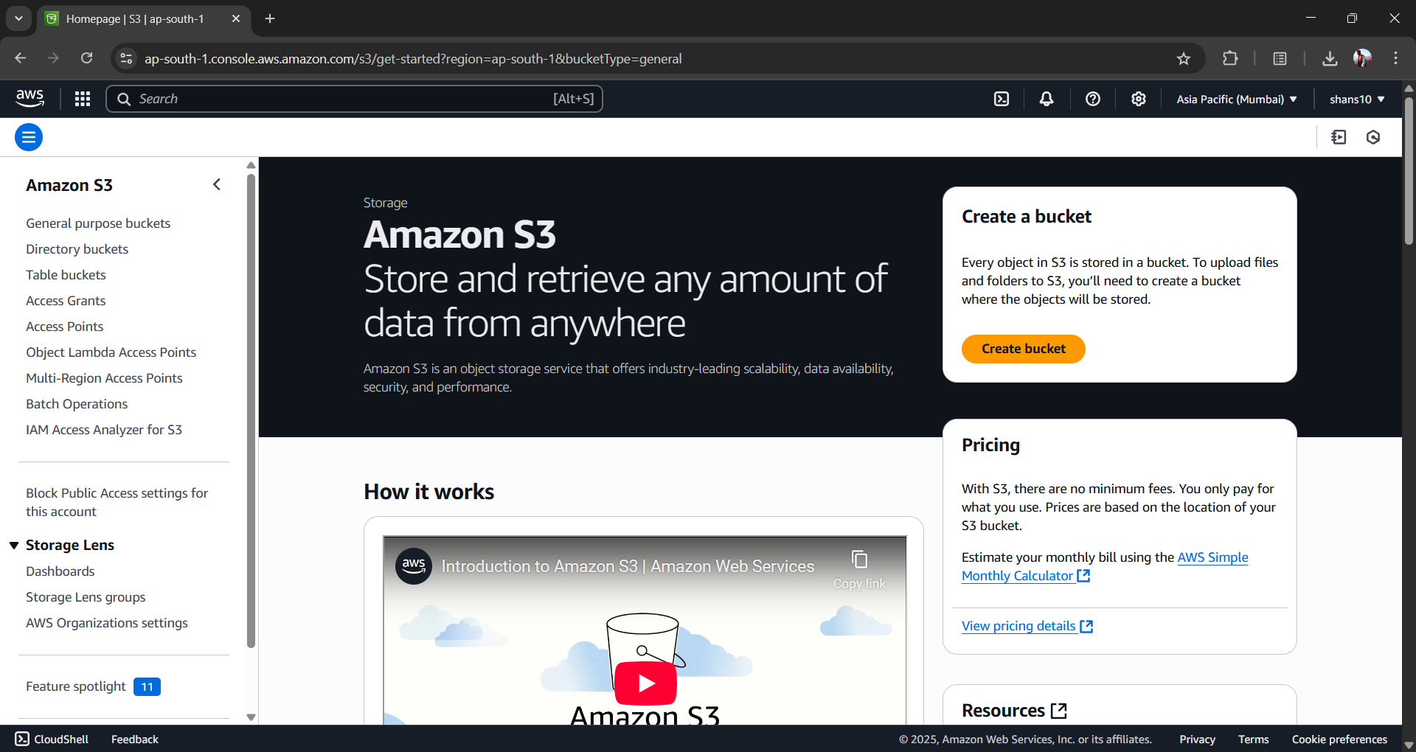

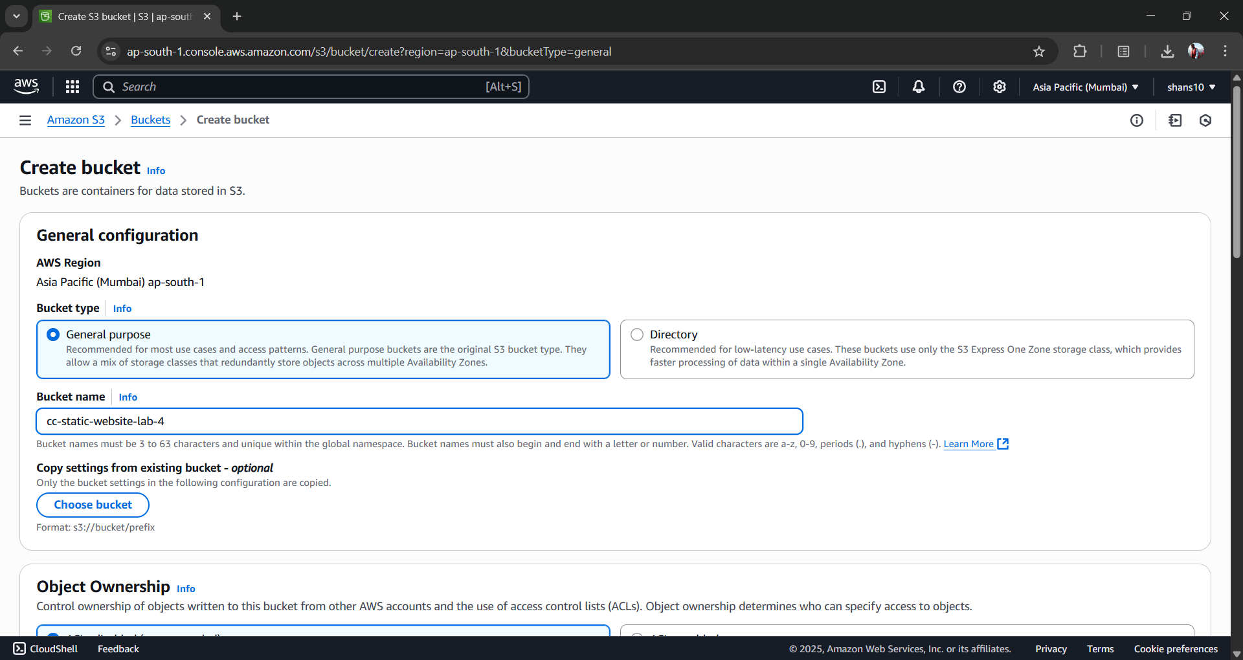

1. *Enable Public Access for the bucket -*

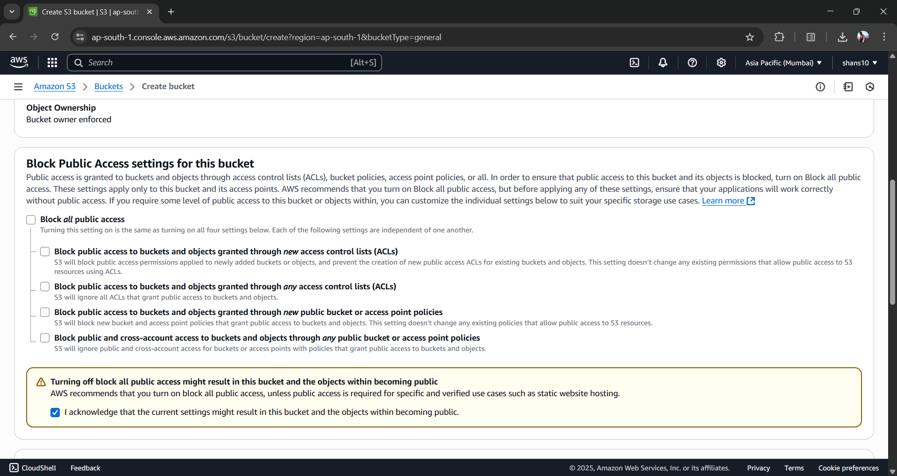

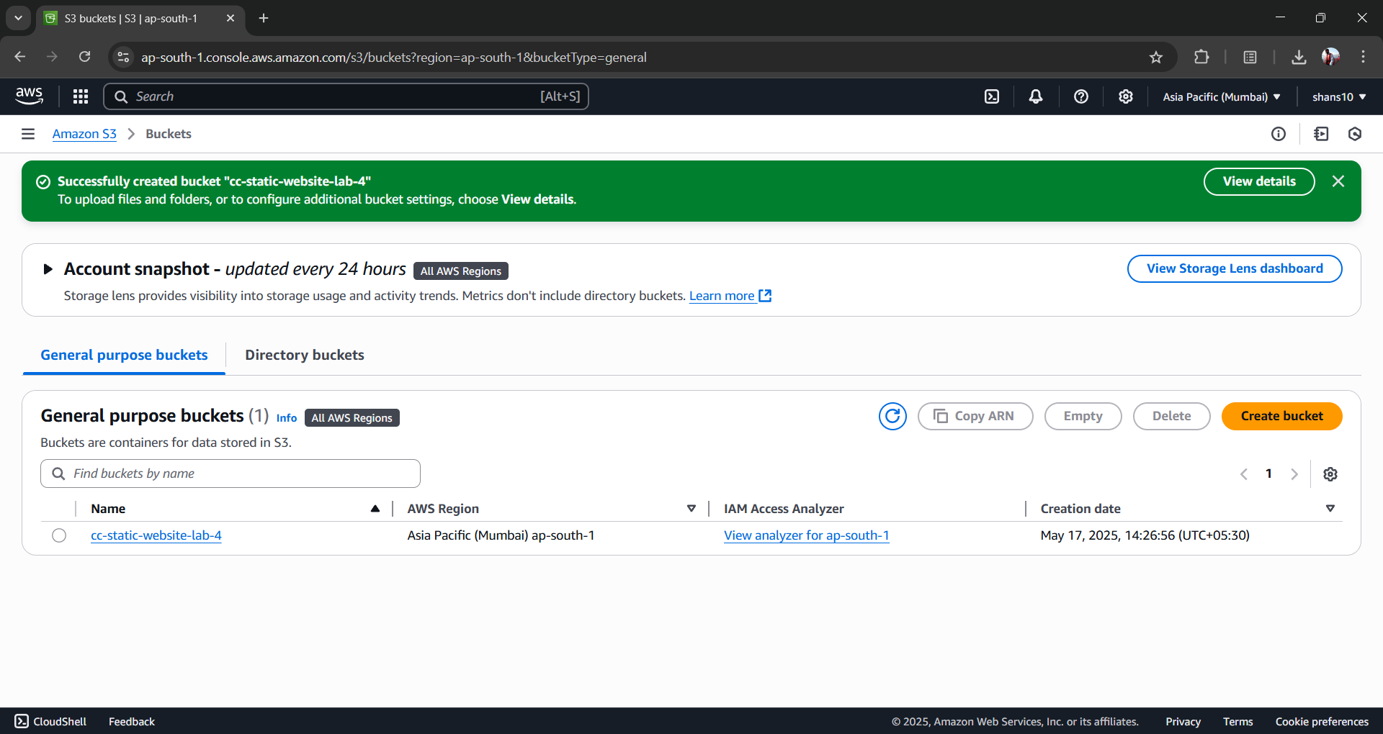

1. *Upload static files for the website -*

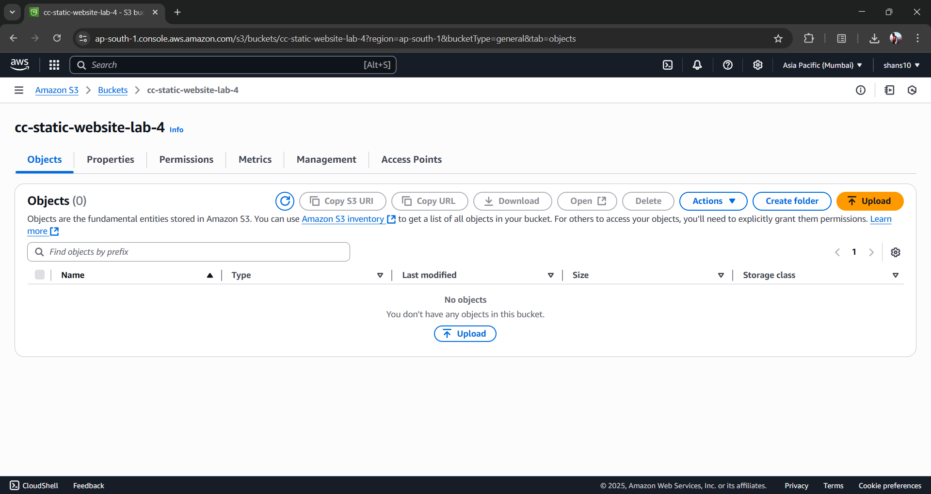

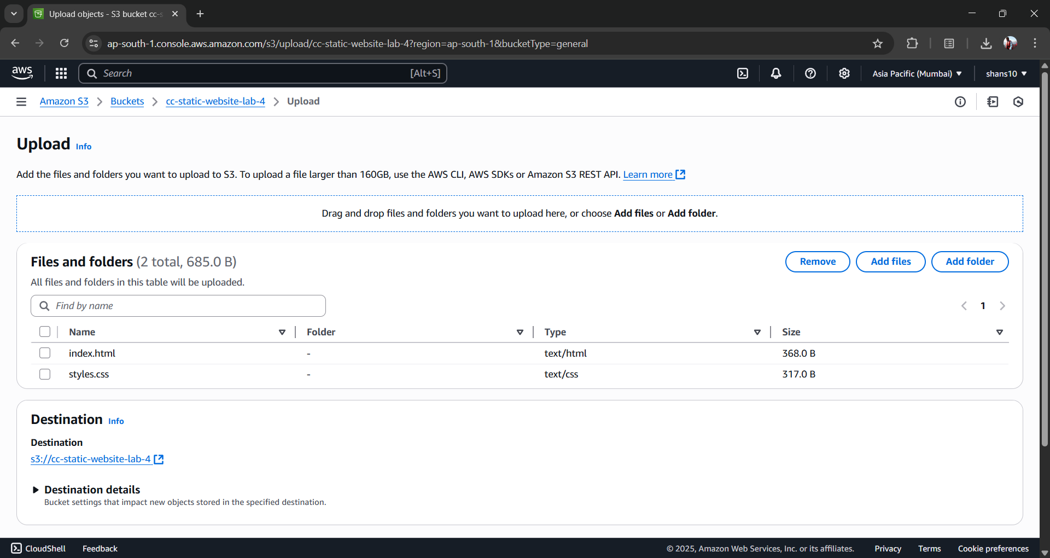

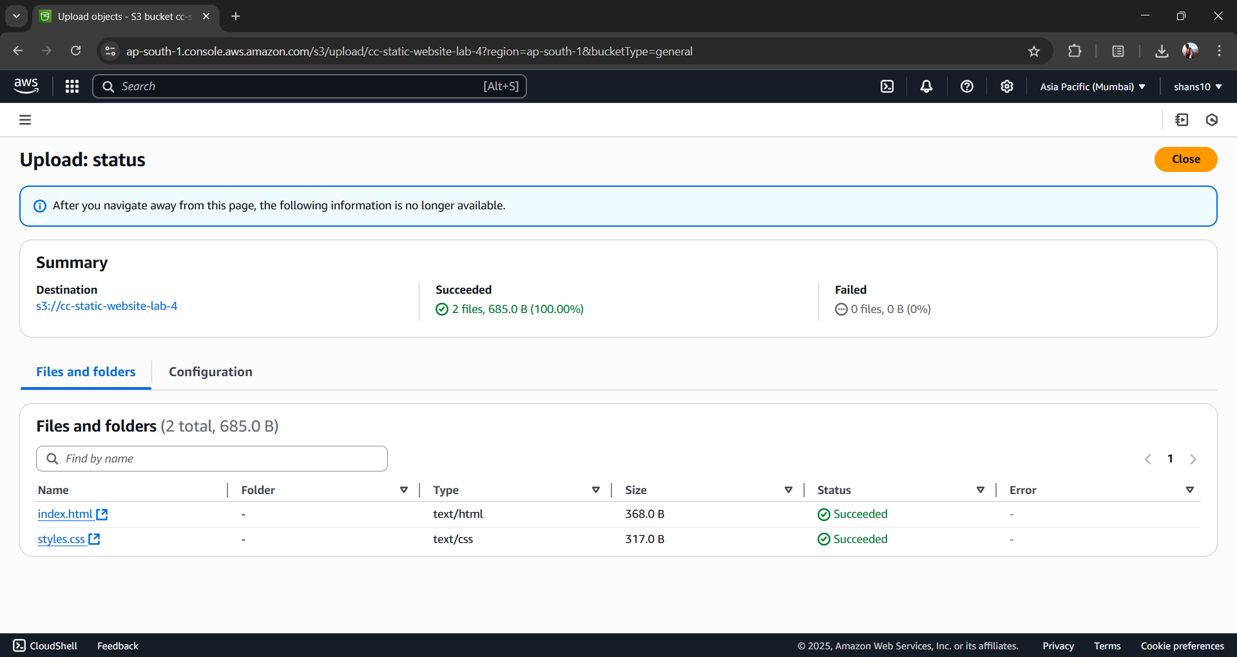

1. *Edit Bucket Policy in permissions to make files publicly readable -*

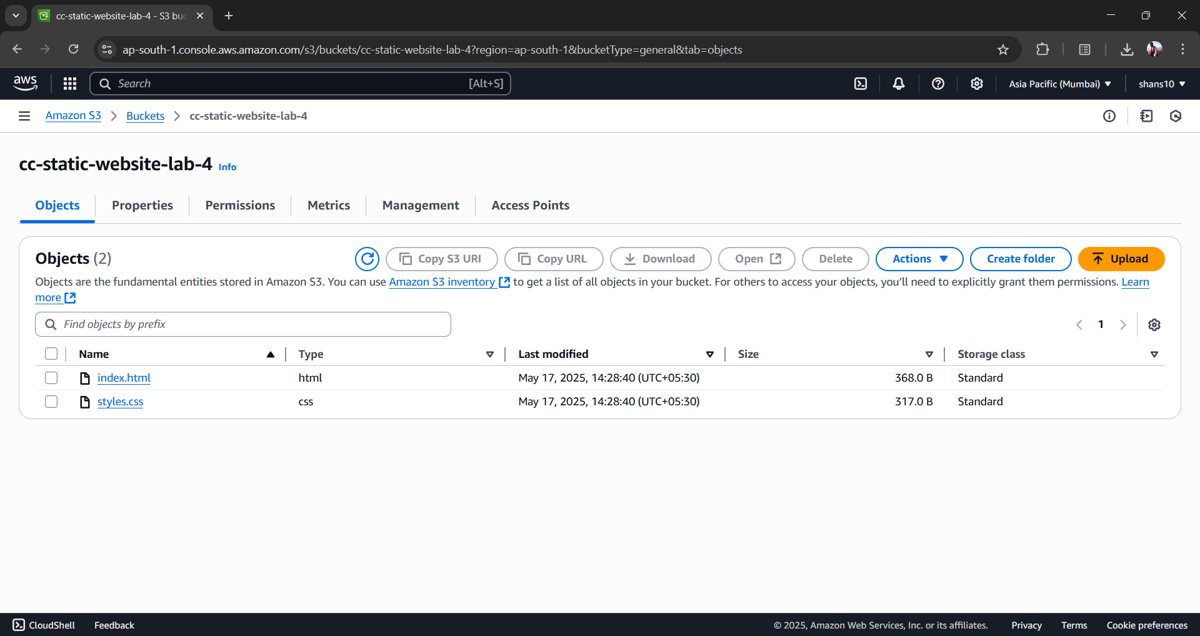

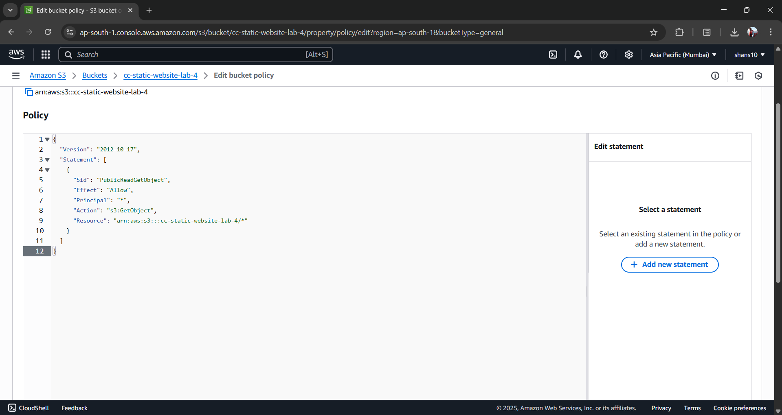

1. *Enable Static Website Hosting -*

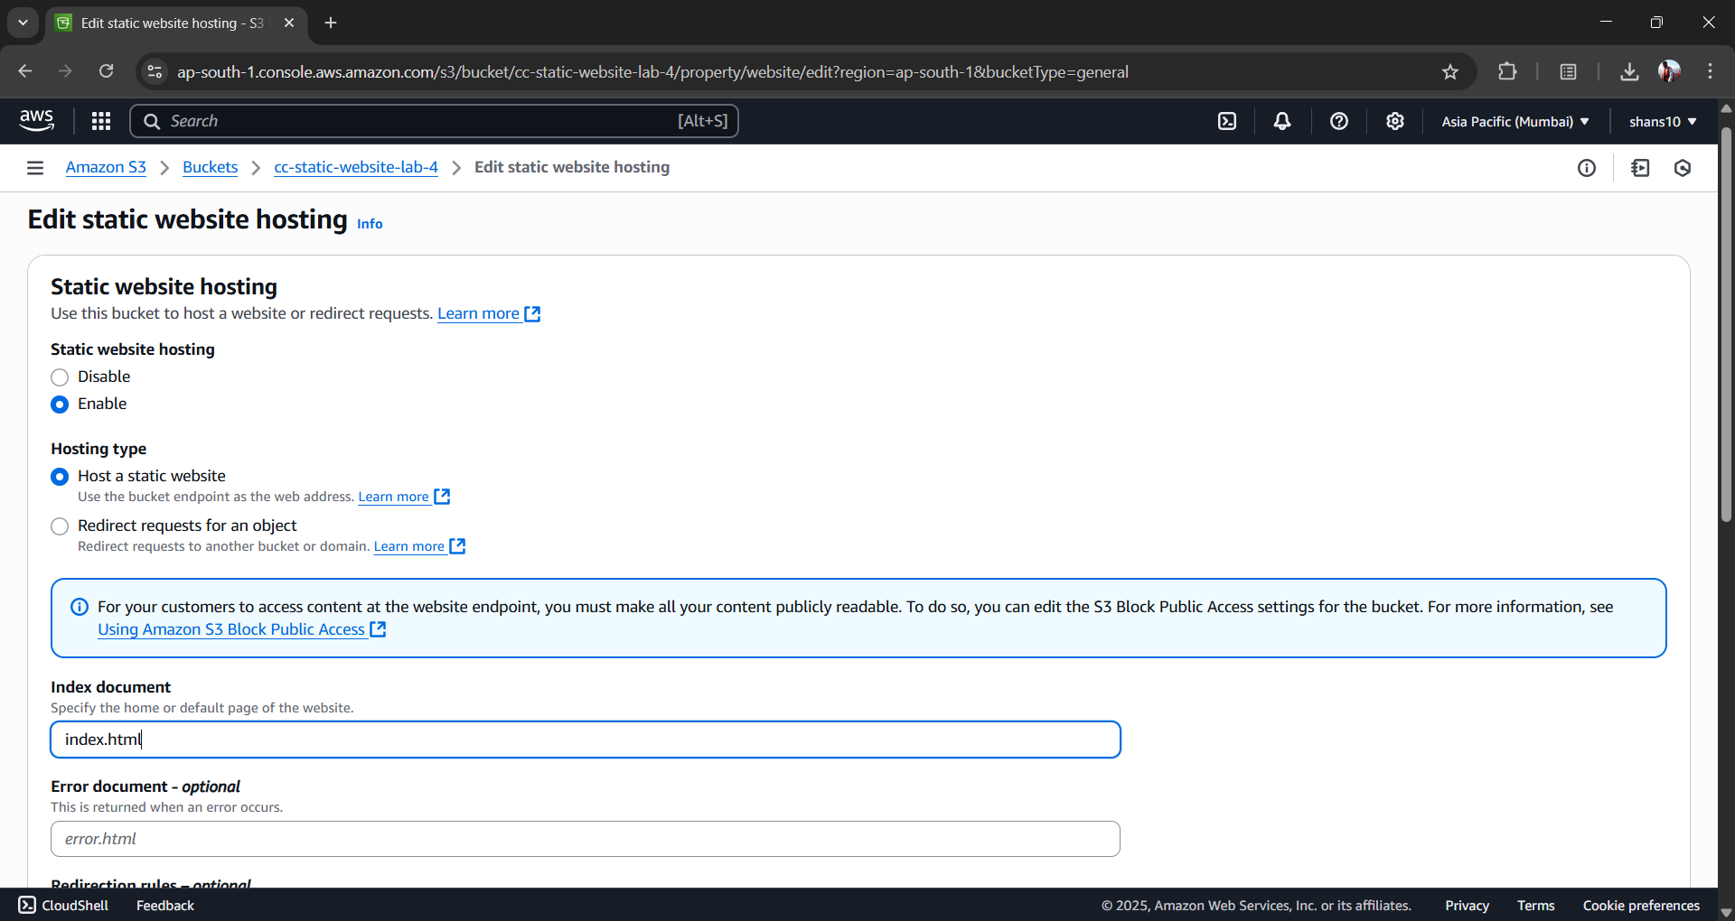

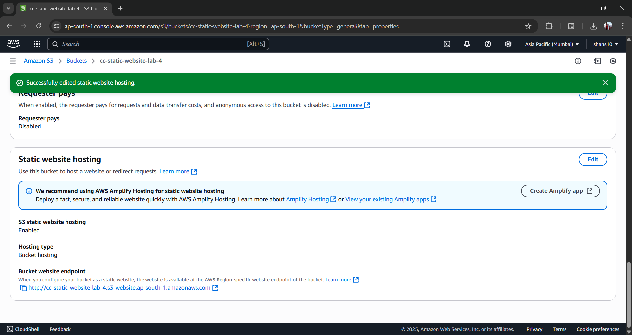

1. *Access the website on the public ip address -*

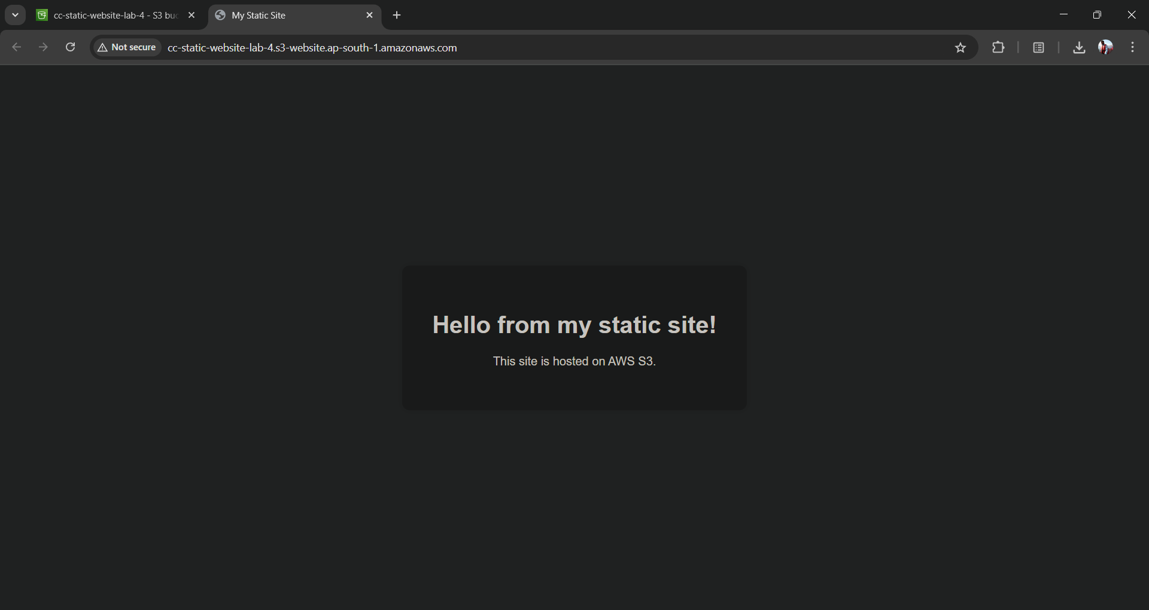

**Lab-5**

**Objective:** Perform a comparative analysis of the services offered by Google, AWS and Microsoft clouds.

**Results:**

**1. Compute Services:**

|  |  |  |  |
| --- | --- | --- | --- |
| **Feature** | **AWS** | **Microsoft Azure** | **GCP** |
| **Virtual Machines** | EC2 | Azure Virtual Machines | Compute Engine |
| **Serverless** | AWS Lambda | Azure Functions | Cloud Functions |
| **Containers** | ECS, EKS, Fargate | AKS, Azure Container Instances | GKE, Cloud Run |
| **App Hosting (PaaS)** | Elastic Beanstalk | Azure App Services | App Engine |
| **Auto Scaling** | Auto Scaling Groups | Virtual Machine Scale Sets | Instance Groups |

**2. Networking**

|  |  |  |  |
| --- | --- | --- | --- |
| **Feature** | **AWS** | **Microsoft Azure** | **GCP** |
| **VPC / Networking** | VPC | Virtual Network | VPC |
| **Load Balancing** | Elastic Load Balancing | Azure Load Balancer / Application Gateway | Cloud Load Balancing |
| **CDN** | CloudFront | Azure CDN | Cloud CDN |
| **DNS** | Route 53 | Azure DNS | Cloud DNS |

**3. Storage and Databases:**

|  |  |  |  |
| --- | --- | --- | --- |
| **Feature** | **AWS** | **Microsoft Azure** | **GCP** |
| **Object Storage** | S3 | Azure Blob Storage | Cloud Storage |
| **Block Storage** | EBS | Azure Disk Storage | Persistent Disks |
| **File Storage** | EFS, FSx | Azure Files | Filestore |
| **Relational DB (SQL)** | RDS (PostgreSQL, MySQL, etc.) | Azure SQL, PostgreSQL, MySQL | Cloud SQL, AlloyDB |
| **NoSQL** | DynamoDB | Cosmos DB | Firestore, Bigtable |
| **Data Warehousing** | Redshift | Synapse Analytics | BigQuery |

**4. AI/ML Services:**

|  |  |  |  |
| --- | --- | --- | --- |
| **Feature** | **AWS** | **Microsoft Azure** | **GCP** |
| **Pre-built AI APIs** | Rekognition, Polly, Comprehend | Azure Cognitive Services | Vision AI, Speech-to-Text, etc. |
| **ML Platform** | SageMaker | Azure Machine Learning | Vertex AI |
| **TPU Support** | No | No | Yes (Tensor Processing Units) |

**5. Developer & DevOps Tools:**

|  |  |  |  |
| --- | --- | --- | --- |
| **Feature** | **AWS** | **Microsoft Azure** | **GCP** |
| **CI/CD** | CodePipeline, CodeBuild | Azure DevOps, GitHub Actions | Cloud Build |
| **IaC (Infrastructure as Code)** | CloudFormation | ARM Templates, Bicep | Deployment Manager, Terraform support |
| **Monitoring** | CloudWatch | Azure Monitor | Cloud Monitoring (Stackdriver) |

**Lab-6**

**Objective:** Create a windows EC2 instance and prepare a database server to be accessed by a web application.

**Results:**

* *Step 1: Launch a Windows EC2 Instance*

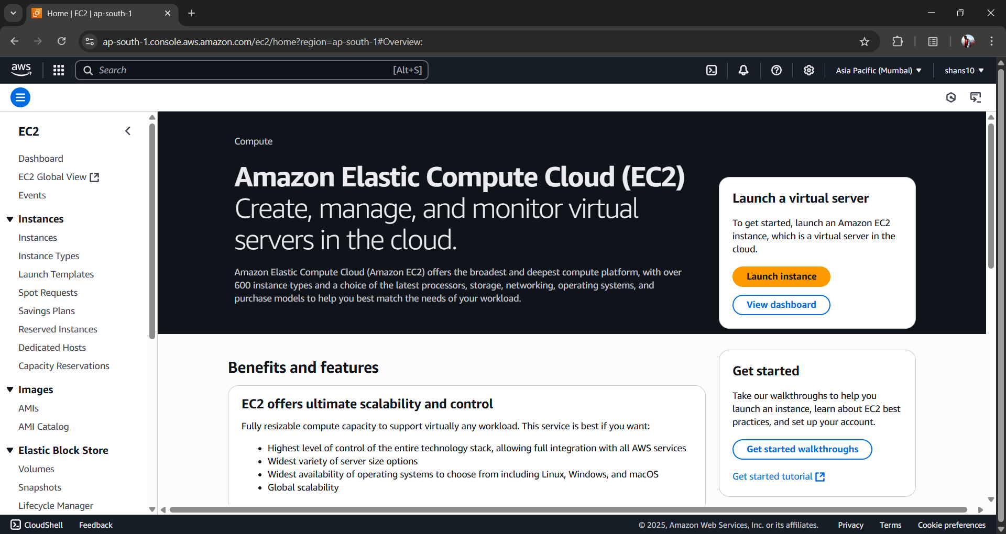

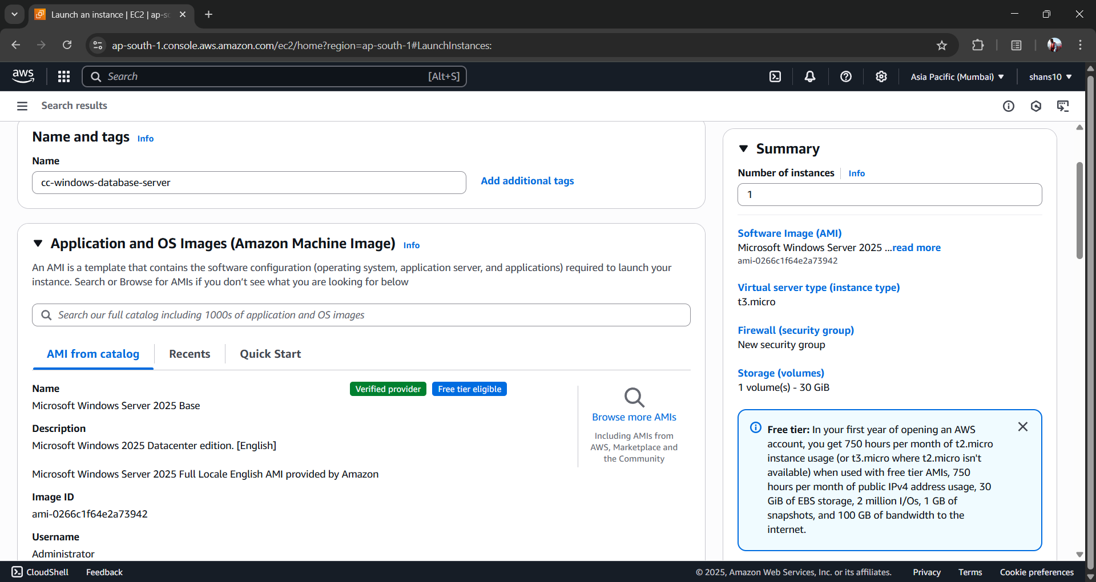

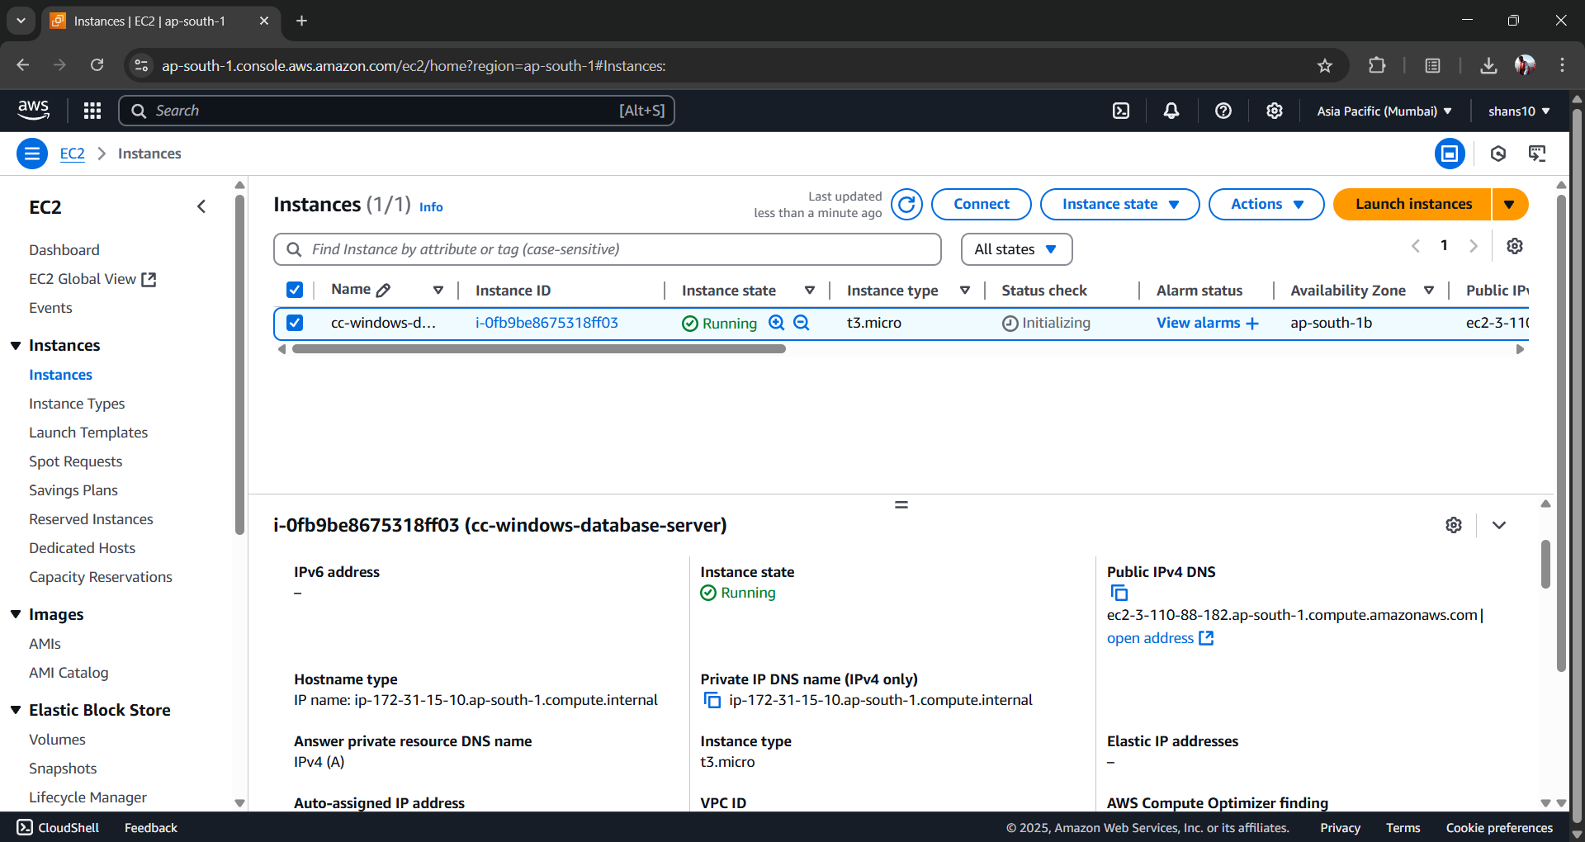

**Checking TCP Port Access for Database Server**

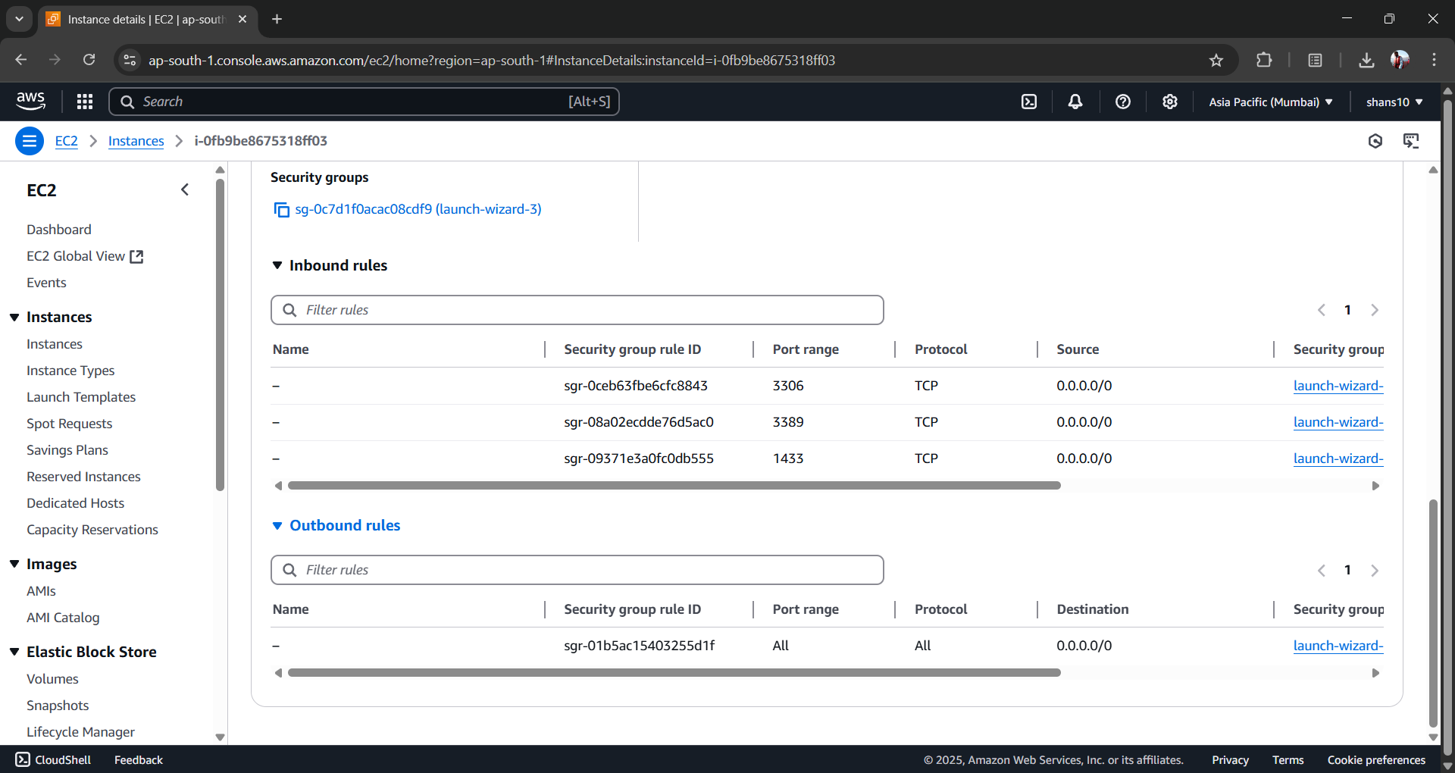

* *Step 2: Connect to the Instance*

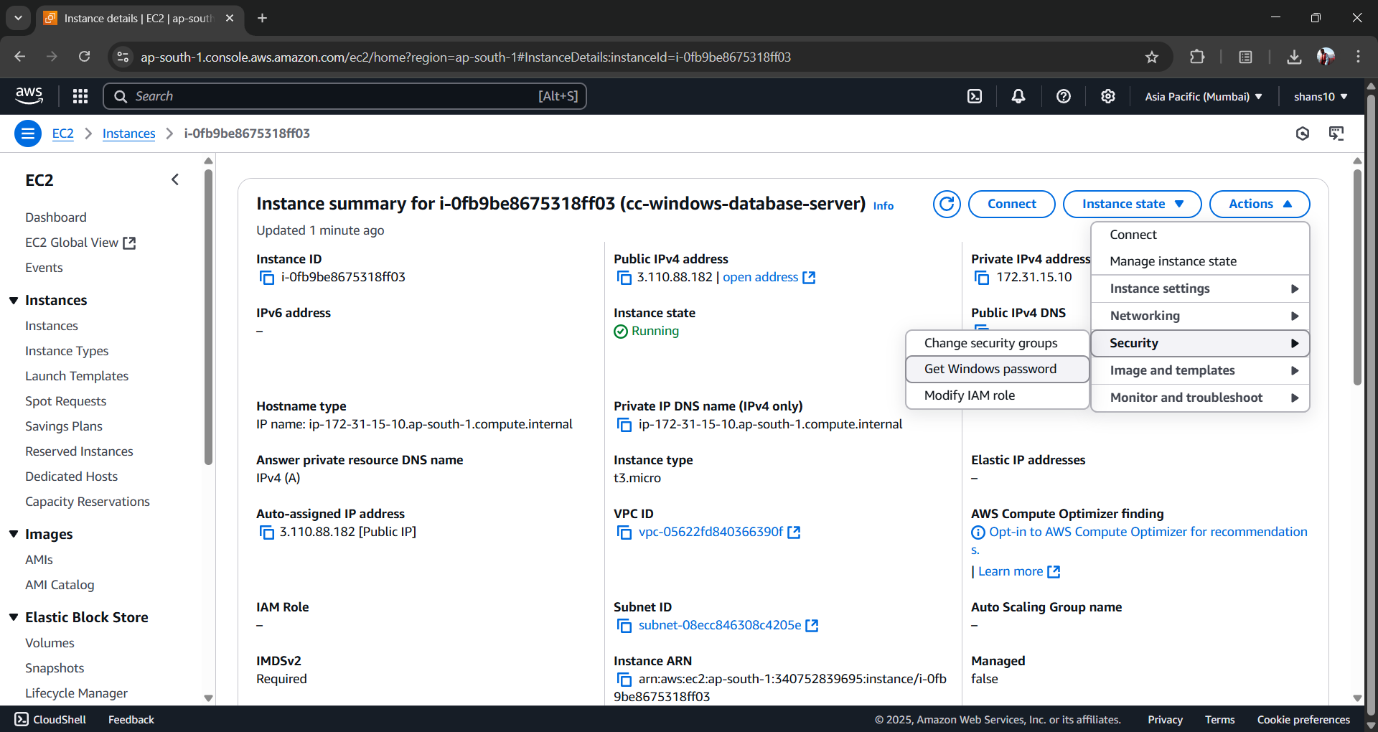

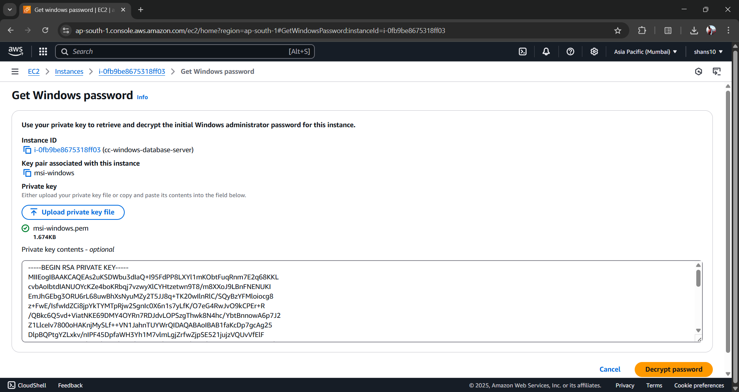

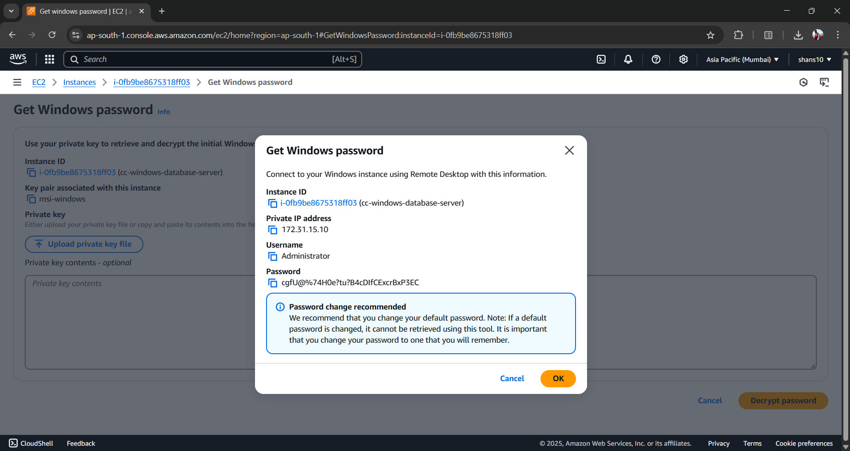

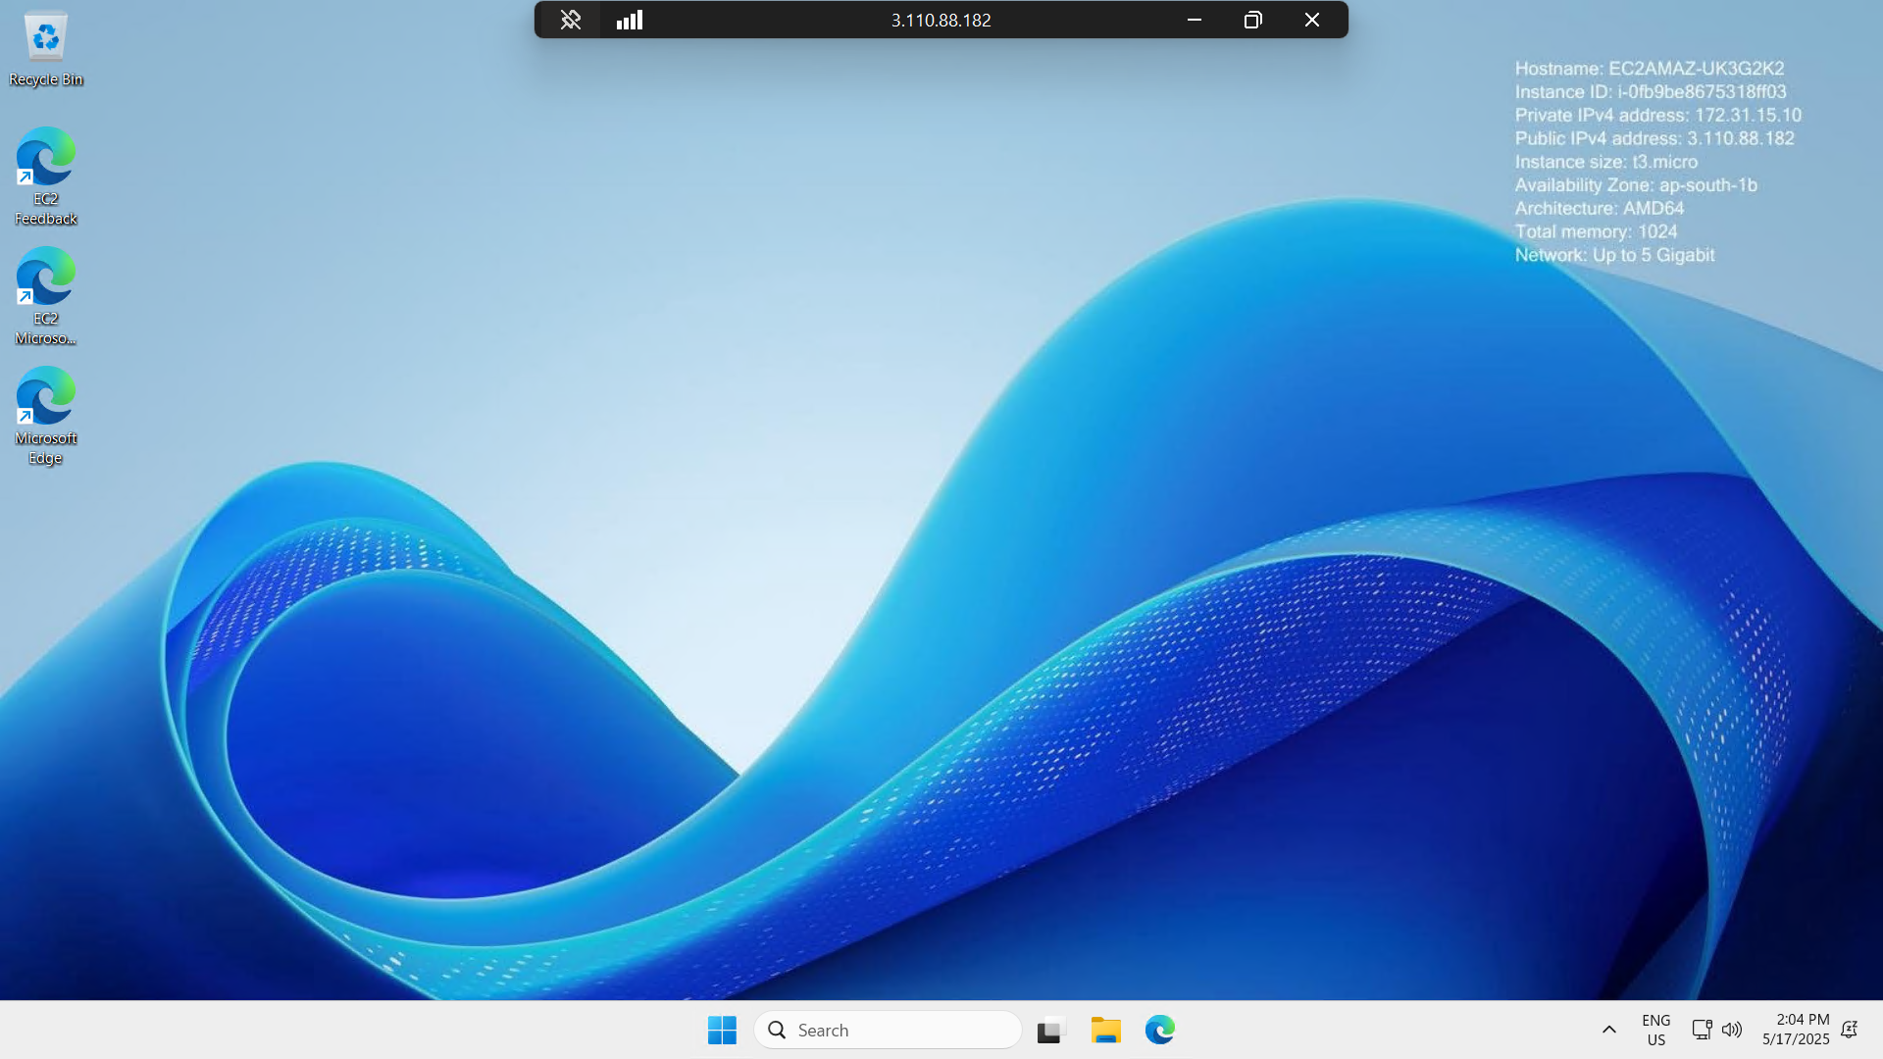

* *Step 3: Install a Database Server*

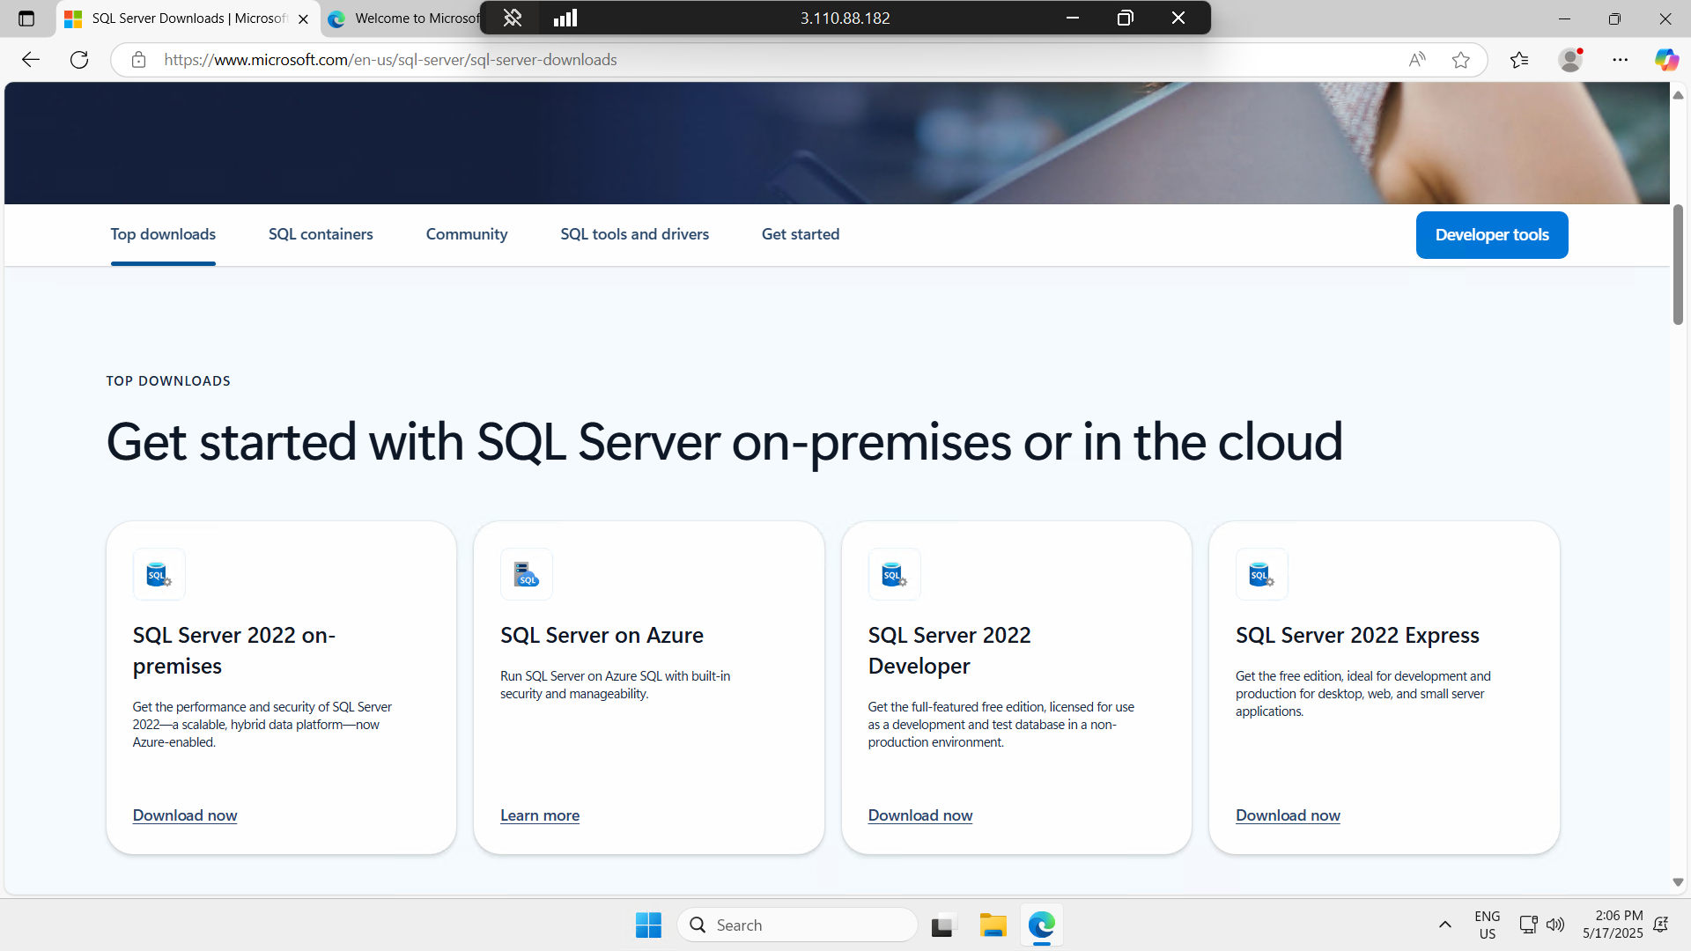

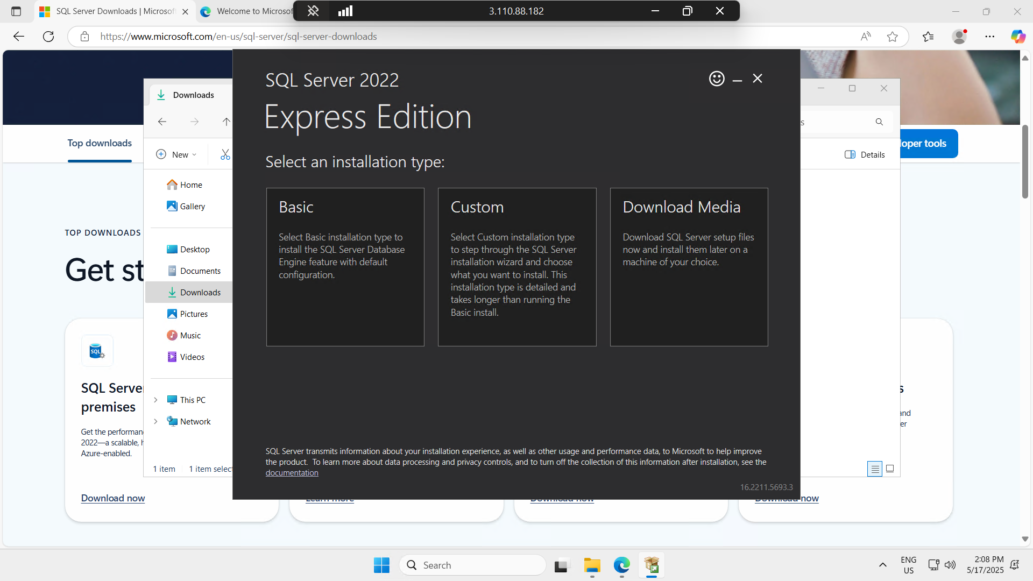

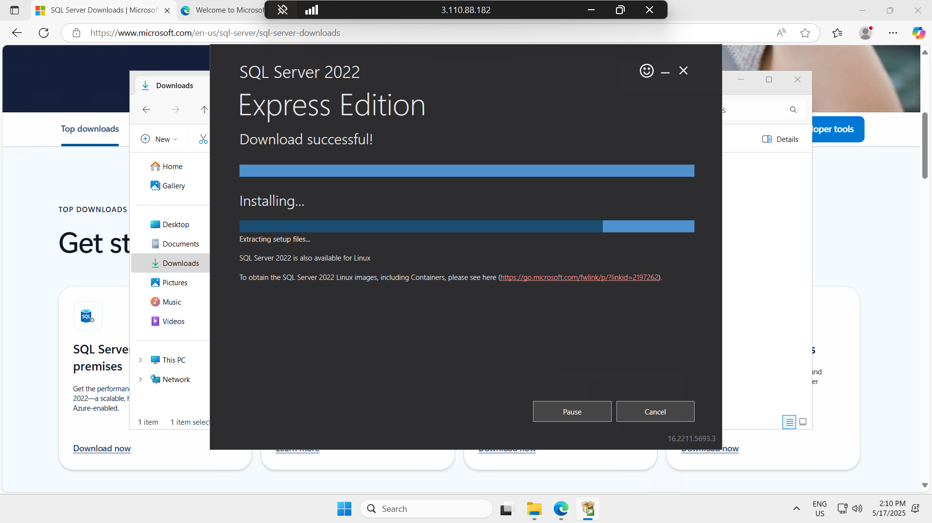

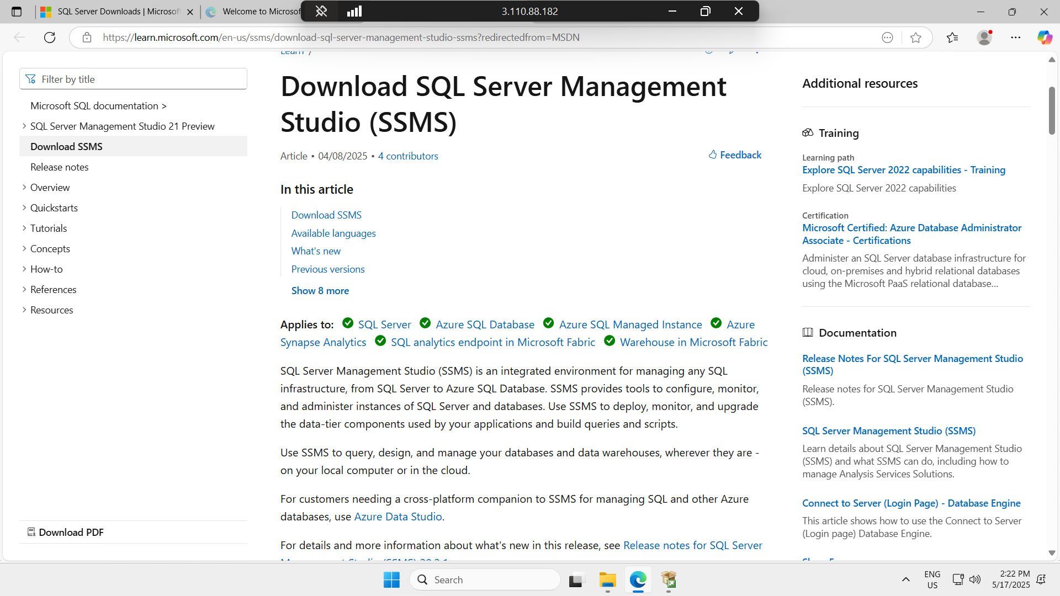

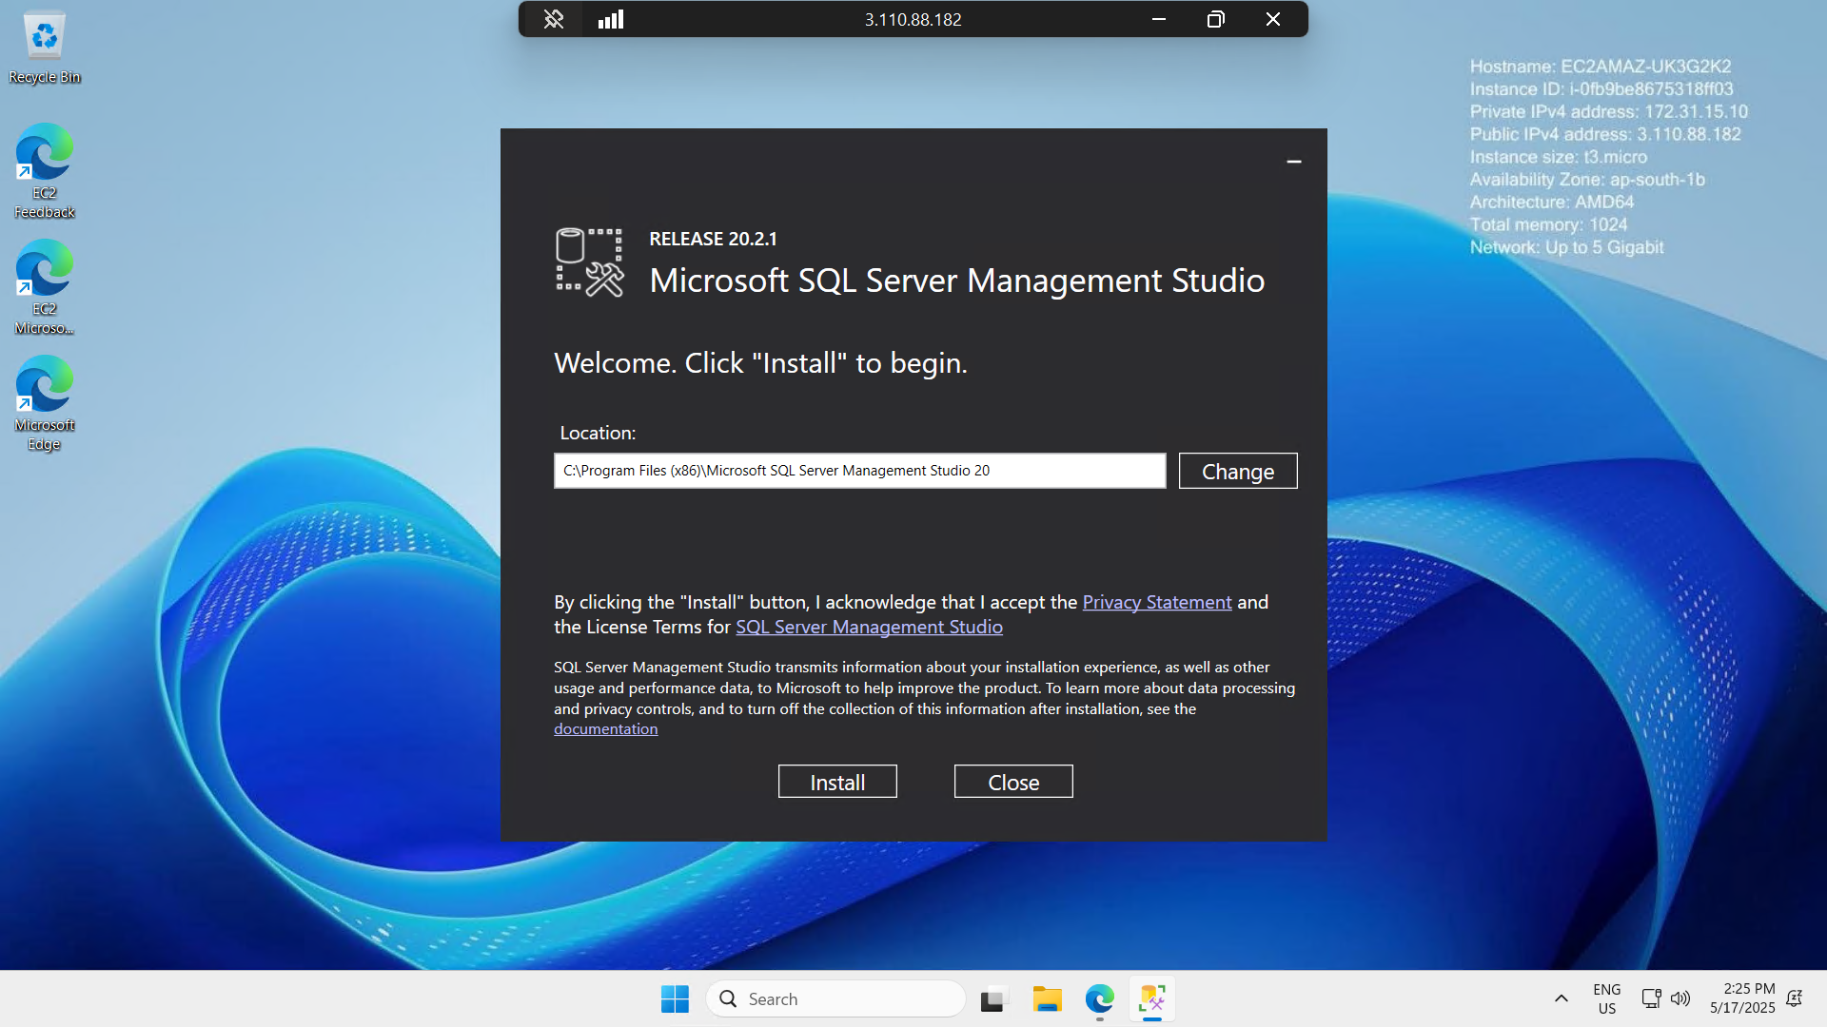

* *Step 4: Configure Database Access*

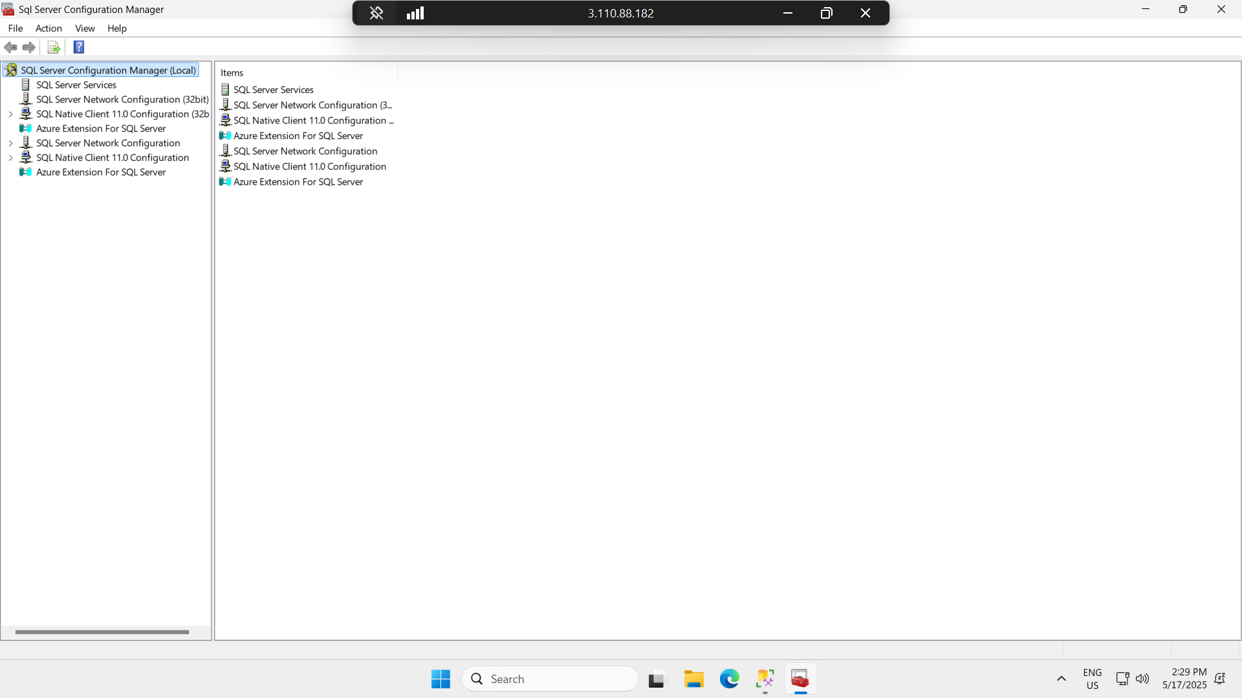

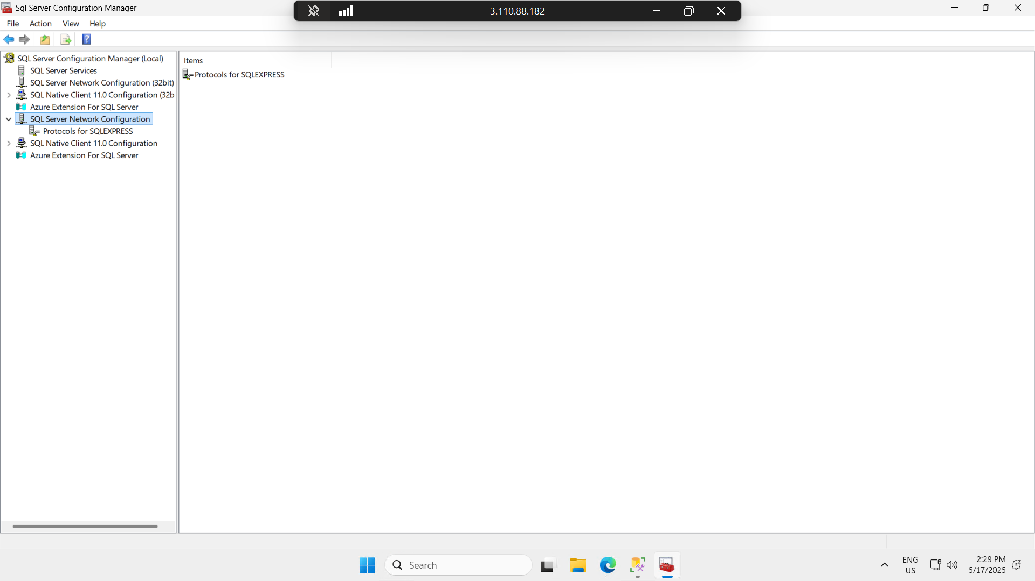

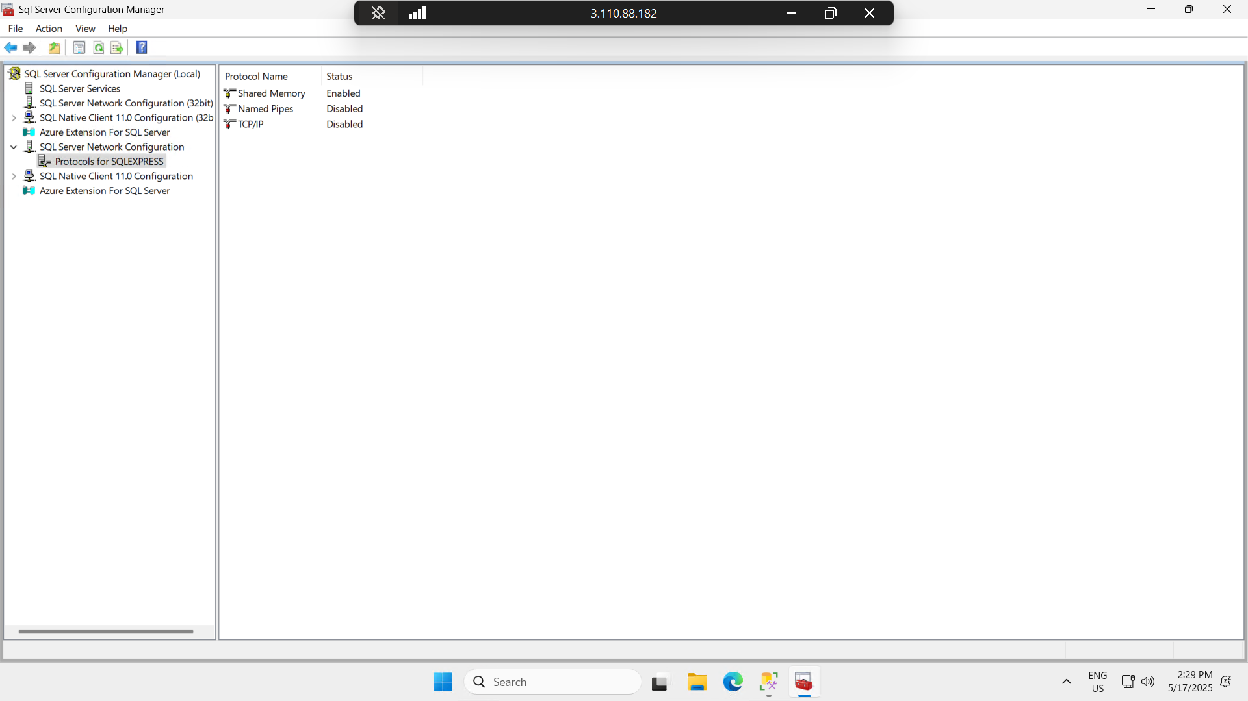

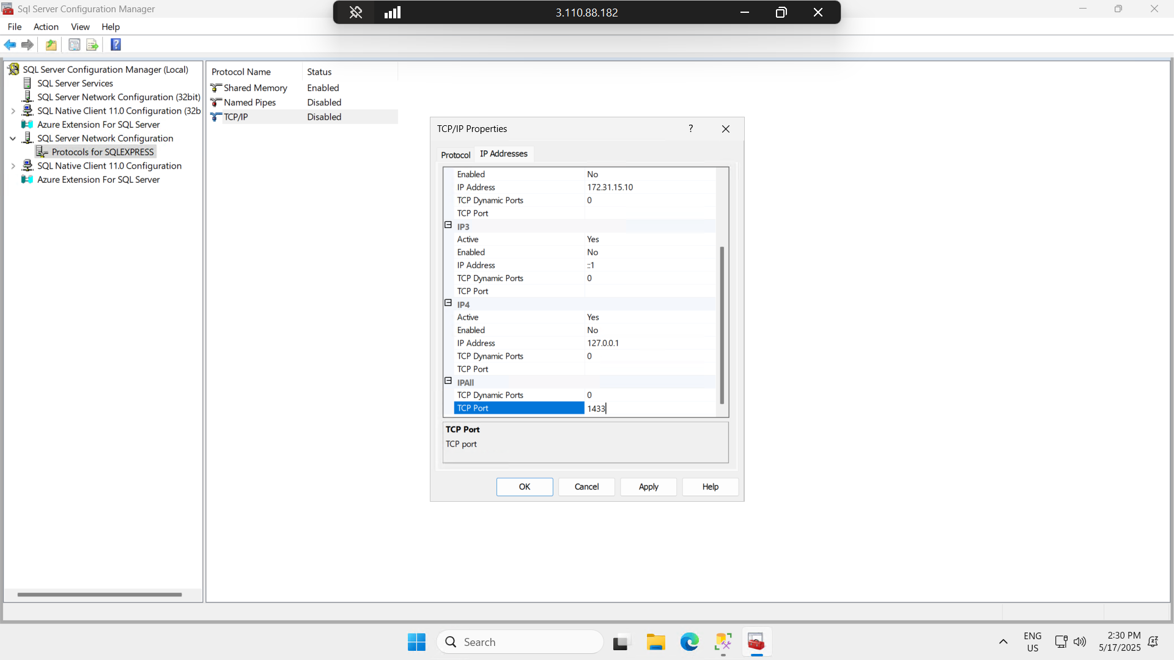

* *Step 5: Allow MSQL Port Through Firewall*

